Chemistry ATAR Year 12
Unit 3

Equilibrium



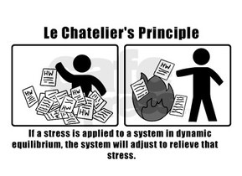

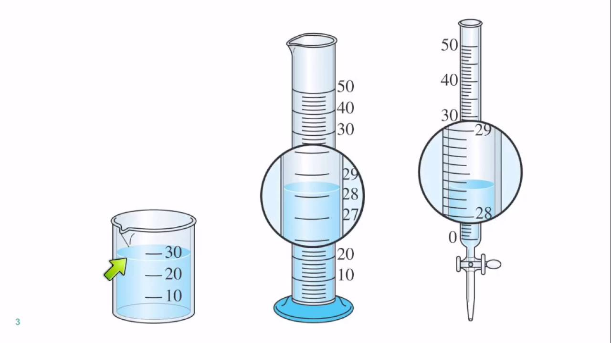
Uncertainty and error

- All measurements involve some degree of uncertainty.
  - More accurate equipment involves less uncertainty.
  - Volume in beaker = ± 2mL
  - Volume in measuring cylinder = ± 0.5 mL
  - Volume in burette = ± 0.05 mL

- With analogue equipment, unless indicated, the uncertainty is ± half of the smallest scale division.
- With digital equipment, unless indicated, the uncertainty is ± 1 of the last significant figure.
  - A balance that reads to 1 dp will have an uncertainty of ± 0.1 g.
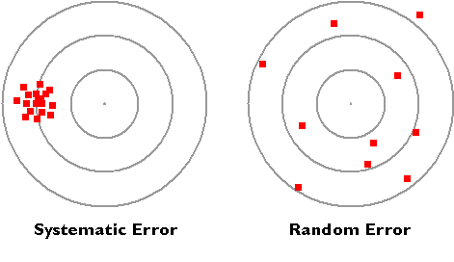
  - A balance that reads to 2 dp will have an uncertainty of ± 0.01 g.

- Random errors have equal chance of being above or below the actual value.
  - They can never be eliminated.
  - Repeat trials minimise random errors.
  - Human reaction times can be random errors.
  - They affect the precision of the result.


- Systematic errors are due to faulty equipment or experimental procedure.
  - They lead to a result that is always above the true value or always below the true value.
  - Poorly calibrated equipment can lead to systematic errors.
  - Faulty equipment can lead to systematic errors.
  - They can’t be eliminated by repeat trials.
  - They affect the accuracy of the result.

    - Label the following as systematic error (S) or random error (R).
      - incorrect etching mark on a volumetric flask
      - careless reading of the liquid level in a burette
      - a fault in a balance, such that it reads 100 mg too heavy
      - allowing a pipette to drain for only 5 s, rather than the recommended 30 s.

- Significant figures are those digits that are known with certainty plus the first uncertain digit.
  - Whole numbers with zeros, such as 430 and 500, are ambiguous.
  - 430 has 2 sf. 500 has 1 sf.
  - 430 has 3 sf if written as 4.30 x 10².

- In tests and exams you may be asked to give an answer to
  - a specific number of sf (e.g 3 sf) or
    - Round the following to three significant figures.

2.456 = 7.34234 = 0.024634 =
0.003463 = 4.3351 = 4.3349 =

- In tests and exams you may be asked to give an answer to
  - the correct number of sf.
  - The answer should be as accurate as the least accurate data in the calculation.
    - Divide 8.3275 by 2.48 and express your answer to the correct number of sf.

    - Solve the following problems to the correct number of sf.
$\frac{5.00 x 0.022 x 22.71}{0.245 x 289.9}=$ $\frac{250 x 4.36}{5.00 x 4.20}=$

Collision theory can be used to explain and predict the effects of concentration, temperature, pressure, the presence of catalysts and surface area of reactants on the rates of chemical reactions.

COLLISION THEORY

- In order for a reaction to occur reactants must collide.

- The collision must have:
  - sufficient energy to break bonds in reactant molecules.
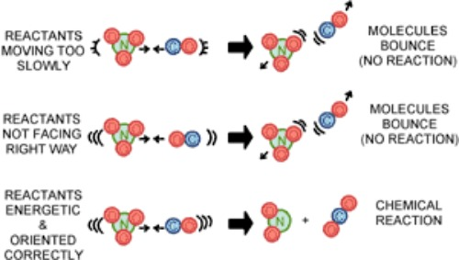
  - the correct orientation that allows bonds in the reactants to be broken and bonds in the products are formed.

RATES OF CHEMICAL REACTIONS
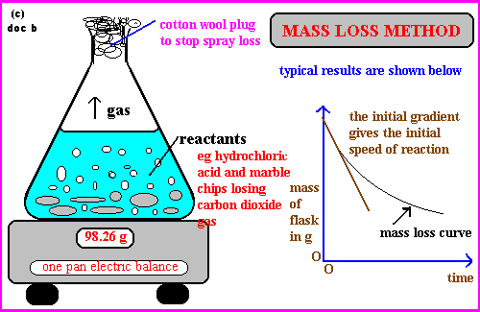

The Concept of Reaction Rate

- A reaction rate be determined by
  - the rate of disappearance of reactants.
  - the rate of appearance of products.

- The rate of a reaction is a measure of the speed at which reactants are consumed or products are produced.
  - rate = # of successful collision per unit time
  -  collisions =  rate of reaction

Factors that Affect the Rate of Reaction

- For each of the following reactions, describe how the rate of reaction changes

    - Solid KI added to solid Pb(NO₃)₂, solution of KI added to a solution of Pb(NO₃)₂.

_________________________________________________________________

_________________________________________________________________

_________________________________________________________________

_________________________________________________________________
    - Magnesium ribbon placed into solutions of 0.1 M, 1.0 M and 4.0 M HCl.

_________________________________________________________________

_________________________________________________________________

_________________________________________________________________

    - 1.0 M HCl poured over marble chips (CaCO₃) and powdered CaCO₃.

_________________________________________________________________

_________________________________________________________________

_________________________________________________________________

    - Alka-Seltzer tablet placed into hot and cold water.

_________________________________________________________________

_________________________________________________________________

_________________________________________________________________

    - 20 vol H₂0₂ has a black powder, MnO₂, added to it.

_________________________________________________________________

_________________________________________________________________

_________________________________________________________________

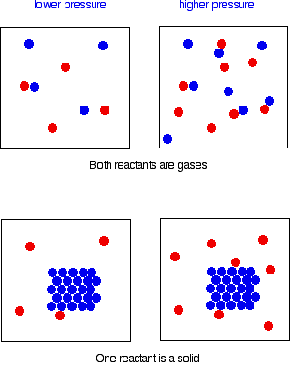
The Nature of the Reactants

- If a reaction does not involve bonding rearrangement it is likely to be rapid at room temperature.
Ag⁺ _{(aq)} + Cl⁻ _{(aq)} AgCl _{(s)}
- If a reaction involves the breaking of bonds it is likely to be slow at room temperature.

CH₄ _{(g)} + 2O₂ _{(g)} 2H₂O _{(g)} + CO₂ _{(g)}
Two gases
One reactant is solid

- To increase the speed of reaction
  - Need less bonds to be broken or weaker bonds to be broken. If strong bonds need to be broken, the reaction is slow.

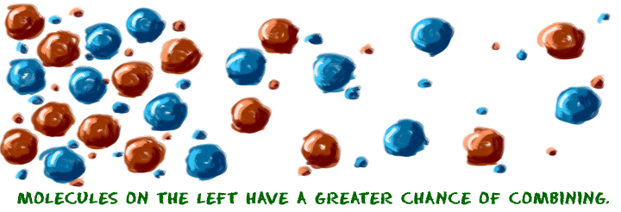
The Concentrations of the Reactants
- Changing the concentration will affect the rate of reaction.
- A higher concentration of reacting particles (more particles per volume) means more collisions are likely to occur between these particles and hence an increase in the rate of reaction.
- An increase in pressure in a gaseous system is the same as increasing the concentration.

- To increase the speed of reaction
  - Need a greater concentration of reactants – higher concentration results in more frequent collisions between reactant particles.

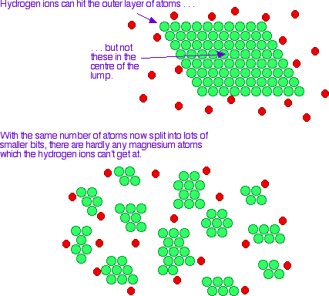
The State of Sub-Division of the Reactants
- For particles to collide, they need to come into contact with each other.
- For a solid, only outside particles can collide.

- By decreasing the size of the surface of the reacting materials (e.g. crushing a solid into a powder, turning a liquid into an aerosol), the rate of reaction increases because it increases the surface area of the reactants.
Smaller surface area in contact
- Increasing the surface area increases percentage of reacting particles colliding. Increased rate of collision and hence the reaction rate rises.

- To increase the speed of reaction
  - Have reactants that are finely divided – increased surface area results in more frequent collisions between particles.
Much larger surface area in contact

Temperature
- Temperature affects speed of particles and energy of particles.
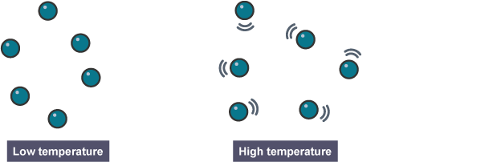
- At higher temperatures particles have greater kinetic energy - greater percentage of collisions have sufficient energy to react.
- Particles are also moving faster – more collisions occur. A greater number of the collisions are successful and hence the reaction rate increases.

- To increase the speed of reaction
  - Have a higher temperature – increased temperature results in more frequent collisions at higher energies. More particles have sufficient energy to react.

Catalysts
- A catalyst
- is a substance that provides an alternative (easier) reaction pathway that requires less energy for a successful reaction.
- does not increase the number of collisions.
- provides a surface for reacting particles to break down easily.
- increases the rate of a chemical reaction.
- is NOT consumed in the reaction.
- is not required in large amounts.
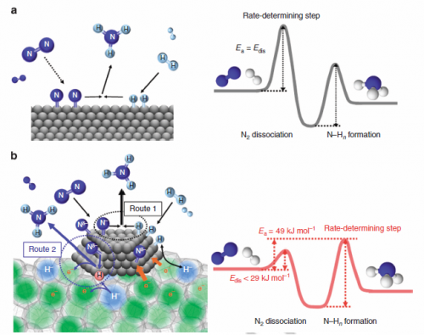
- As a result, a greater percentage of collisions require less energy to successfully react - more collisions are more successful and reaction rate increases.

- To increase the speed of reaction
  - Use a catalyst – it provides a pathway that is easier for particles to react, resulting in more successful collisions.

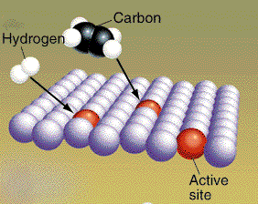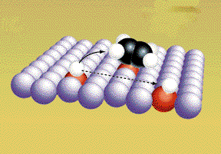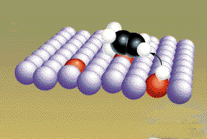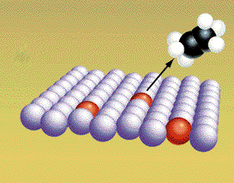

- NOTE: When asked to explain anything to do with rates of reactions, use the Collision Theory. Consider how it is possible to create more collisions.

    - Predict the effect of adding more H⁺ on the rate of the forward and reverse reaction.
Assume the rates of the forward and reverse reactions are initially the same.

Mg_{(s)} + 2H⁺_{(aq)} ⇋ Mg²⁺_{(aq)} + H_{2(g)}

_________________________________________________________________

_________________________________________________________________

_________________________________________________________________

_________________________________________________________________

_________________________________________________________________

0
1
2
3
4
5
6
Time (min)

H₂ + Mg²⁺
H⁺ + Mg
The rates are the same
Reverse rate increases – over time
Forward rate decreases – over time
New equilibrium – must be higher than before – more particles reacting.
H⁺ added. More particles, more collisions. Reaction rate rapidly increases.
RATE

    - Predict the effect of removing Ba²⁺ on the rate of the forward and reverse reaction.
Assume the rates of the forward and reverse reactions are the same

Ba²⁺_{(aq)} + SO₄²⁻_{(aq)} ⇋ BaSO_{4(gs)}

_________________________________________________________________

_________________________________________________________________

_________________________________________________________________

_________________________________________________________________

_________________________________________________________________
0
1
2
3
4
5
6
Time (min)

Ba²⁺ + SO₄²⁻
BaSO₄
The rates are the same
Forward rate increases – over time
Reverse rate decreases – over time
New equilibrium – must be lower tha before – less particles reacting.
Ba²⁺ removed. Less particles, less collisions. Reaction rate rapidly decreases.
RATE

- Time = money. Fast rate means more economical process

Chemical systems include physical changes and chemical reactions and may be open (which allow matter and energy to be exchanged with the surroundings) or closed (which allow energy, but not matter, to be exchanged with the surroundings).

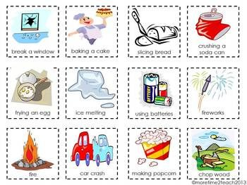
Physical and Chemical Changes

- Changes that occur in a chemical system can be described as a
  - physical change or
  - chemical change.

  - During a physical change

    - no new substances are formed
    - physical properties of the substance change

- During a chemical change
    - new substances are formed
    - chemical and physical properties of the substance change

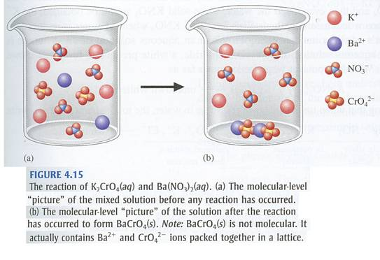

Chemical Systems

- Chemicals involved in a reaction form the chemical system.

- Anything around the chemicals but not involved in the reaction form the surroundings.

- Chemical systems can be
  - open system – substances (matter) and energy can be added or lost.
  - closed systems – chemical reaction contained in a closed space. Only energy can be gained or lost.
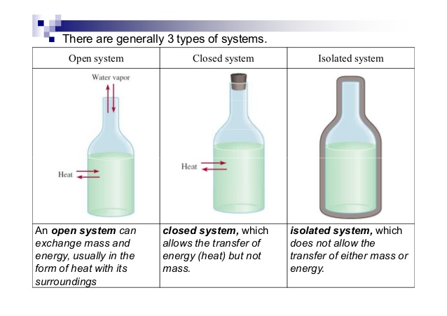
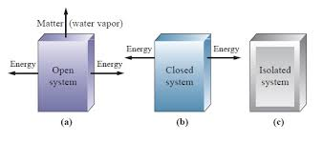


    - State the requirements for a closed system.

_________________________________________________________________

_________________________________________________________________

Observable changes in chemical reactions and physical changes can be described and explained at an atomic and molecular level.

- Physical changes involve a change in form of the chemical substance but not a change in the composition.

- At a molecular level, particles can be moved around but are not chemically altered.
- No chemical bonds are broken.
- No chemical bonds are formed

  - When ice melts, the H₂O molecules remain intact but move apart due to extra energy.
Observable change – water melting

Molecular level

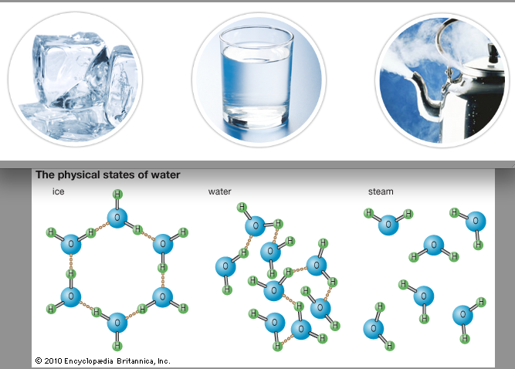
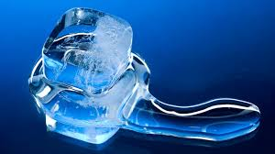

H₂O_{(s)} H₂O_{(l)} H₂O_{(g)}

  - When sugar dissolves in water, the sugar molecules remain intact but are separated due to attraction to the water molecules.
Molecular level

Observable change – sugar disappears

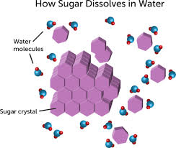
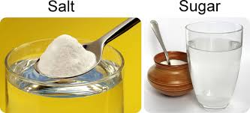

- Chemical changes involve the breaking of bonds and the formation of new bonds.
- New substances are formed.
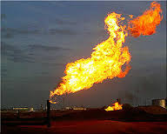
Molecular level

Observable change – methane burning

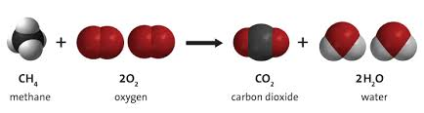

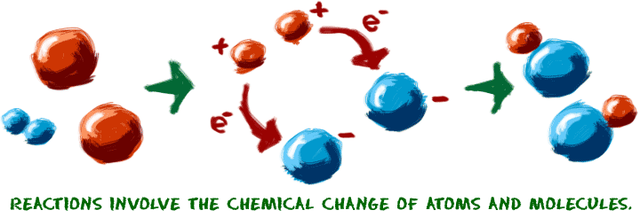

bonds form

bonds break

Over time, in a closed system, reversible physical and chemical changes may reach a state of dynamic equilibrium, with relative concentrations of products and reactants defining the position of the equilibrium.

DYNAMIC CHEMICAL EQUILIBRIUM

Defining Chemical Equilibrium

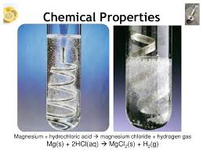
- A chemical reaction involve reactants combining to form products. The products can also combine to form the reactants – a reversible reaction.

- Chemical reactions don’t just go in one direction. All reactions are reversible, although in some reactions one direction may be highly favoured.
e.g. HCl_{(aq)} + Mg_{(s)} → H_{2(g)} + MgCl_{2(aq)}

→ indicates that the forward reaction is much more favoured.

- In the reaction, SO₂Cl_{2 (g)} ⇋ SO_{2(g)} + Cl_{2(g)},
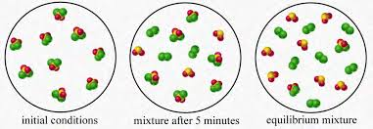

- initially there is only SO₂Cl_{2(g)}.
- as time progresses SO₂ and Cl₍₂₎ form.
- the SO₂ and Cl₍₂₎ begin to combine to form SO₂Cl_{2 (g)}.
- eventually, the system reaches equilibrium where rate at which SO₂Cl₂ disintegrates is equal to the rate at which SO₂ and Cl₍₂₎ combine.

    - What doe the ⇋ mean?

_________________________________________________________________

- For the chemical reaction, NO_{2(g)} + CO_{(g)} ⇋ NO_{(g)} + CO_{2(g)},
- the forward reaction is NO_{2(g)} + CO_{(g)} ⇋ NO_{(g)} + CO_{2(g)},
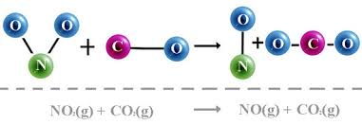

- the reverse reaction is NO_{(g)} + CO_{2(g)} ⇋ NO_{2(g)} + CO_{(g)}.




- In a closed system, a reversible reaction can come to DYNAMIC EQUILIBRIUM – a steady state.
- amounts of reactants and products remain constant.
- forward and reverse reaction are still occurring.
- Equilibrium is the constancy of macroscopic properties in a closed system. It is dynamic because reactions are still occurring but they are equal and opposite to each other.

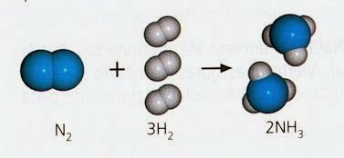
- Consider the production of ammonia. N_{2(g)} + 3H_{2(g)} ⇋ 2NH_{3(g)}

- When nitrogen and hydrogen are mixed in a closed container, under suitable conditions, the forward reaction begins and ammonia forms. That is,
- the concentration of N₂ and H₂ decreases and the concentration of NH₃ increases.
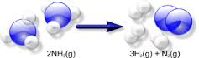
- collisions between reactant molecules gradually decrease.
- when enough NH₃ is formed the reverse reaction becomes possible.
2NH_{3(g)} ⇋ N_{2(g)} + 3H_{2(g)}
- as more NH₃ is produced the reverse reaction increases.

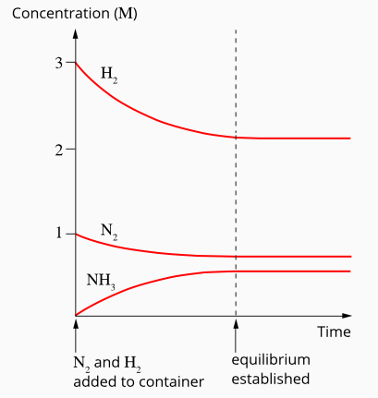
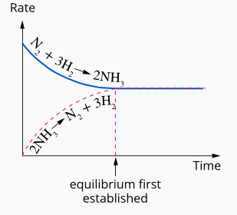

- This equation is reversible which implies
- it does not go to completion.
- as reactants combine to form products, the products regenerate the reactants.
- eventually the rate of the forward and reverse reactions will be the same and a CHEMICAL EQUILIBRIUM is established.
- if conditions change to favour either reaction, then it will proceed at a greater rate
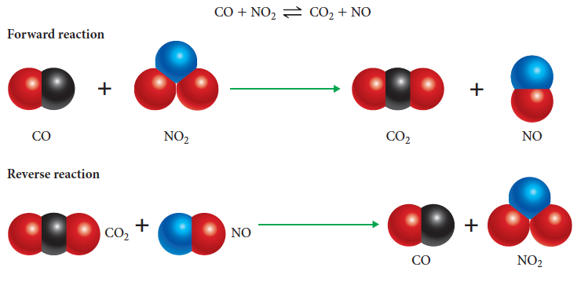
    - State the requirements for a dynamic equilibrium.

_________________________________________________________________

_________________________________________________________________

_________________________________________________________________

Position of the equilibrium

- When a system reaches equilibrium, it is likely that concentration of the reactants will be different from the concentration of the products.

- If the concentration of the products was greater that the reactants, it could be said that
- “the position of the equilibrium lies towards the products” or
- “the position of the equilibrium lies towards the right-hand side”.

- If the conditions of an experiment change, the equilibrium mixture will also change.
- If the change favours the reactants, it could be said that
- “the position of the equilibrium has moved towards the reactants” or
- “the position of the equilibrium has moved towards the left-hand side”.

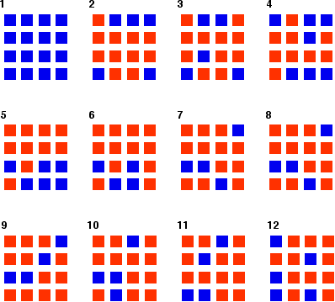
- In this example, a blue square can “react” to become red.
  - Once a red is made, it can react to become blue.
  - Eventually, equilibrium is reached.
  - The rate at which bluered = rate at which redblue.
  - Dynamic equilibrium is reached blue ⇋ red.
  - Since there are more red, the position of the equilibrium lies towards the red.

The characteristics of a system in dynamic equilibrium can be described and explained in terms of reaction rates and macroscopic properties.

Equilibrium in Chemical Systems

- At equilibrium, in a closed system, two equal but opposing reactions are proceeding at the same rate.
- At a macroscopic level, there appears to be no observable changes.
  - Colour remains constant.
  - Pressure remains constant.
  - Temperature remains constant.
  - Concentrations of reactants and products remain constant.
  - Density remains constant.

    - Chemical equilibrium is dynamic rather than static – it may appear to be inactive but reactions are still occurring.
- The reaction has not stopped.
- Equal but opposing rates of reaction – forward and reverse reactions occur (on a molecular level) but at equal rates.
- At the microscopic level, changes are continually occurring.
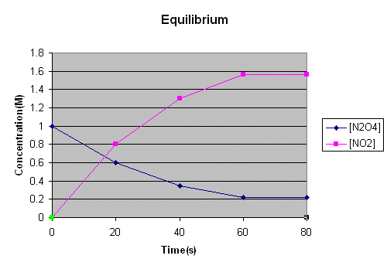
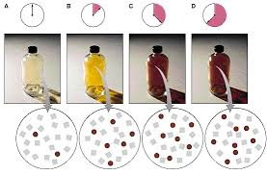
- For example, N₂O_{4(g)} ⇋ 2NO_{2(g)}

  - Initially, there is a high amount of colourless N₂O_{4(g)} and a low amount of brown NO_{2(g)}.
  - Over time the N₂O_{4(g)} turns into brown NO_{2(g)}.
  - As NO_{2(g)} builds up, it will react to form back into N₂O_{4(g)}.
  - Eventually, a steady state will exist and equilibrium will be reached.
  - The rate at which N₂O_{4(g)} is turning into NO_{2(g)} will equal the rate at which NO_{2(g)} is turning into N₂O_{4(g)}.
  - The rate of each reaction is the same.

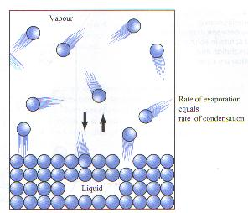
Equilibrium in physical systems

- The essential features of dynamic equilibrium are present in simple physical systems such as phase equilibria and solubility equilibria - composition, density and colour remain constant.
- Equilibrium between liquids and vapour in a closed system.
For example:
H₂O_{(l)} ⇋ H₂O_{(g)}
  - The rate at which liquid water become vapour = the rate at which vapour becomes liquid.
  - Evaporation rate = condensation rate.
  - If the temperature of the system increases, equilibrium no longer exists. Rate of evaporation increases.
  - Eventually, equilibrium would be re-established in a closed system.
- Equilibrium between undissolved solid and dissolved solute in a saturated solution.
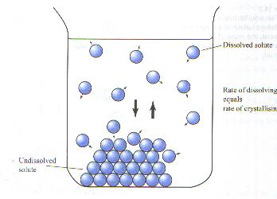
For example:
C₁₂H₂₂O_{11(s)} ⇋ C₁₂H₂₂O_{11(aq)}
  - The rate at which solid sugar is dissolving = the rate at which aqueous sugar is crystallising.
  - Altering the temperature will result in the system no longer being in equilibrium since the rates of the processes of dissolving and crystallising will be changed.
  - Eventually, equilibrium will be re-established.

- All physical changes are reversible and can reach equilibrium.

    - Describe what you would observe in a system at equilibrium.

_________________________________________________________________

_________________________________________________________________

The reversibility of chemical reactions can be explained in terms of the activation energies of the forward and reverse reactions.

COLLISION THEORY AND ACTIVATION ENERGY

Energy Profile Diagrams
- An energy profile diagram represents the energy changes that occur during a chemical reaction.

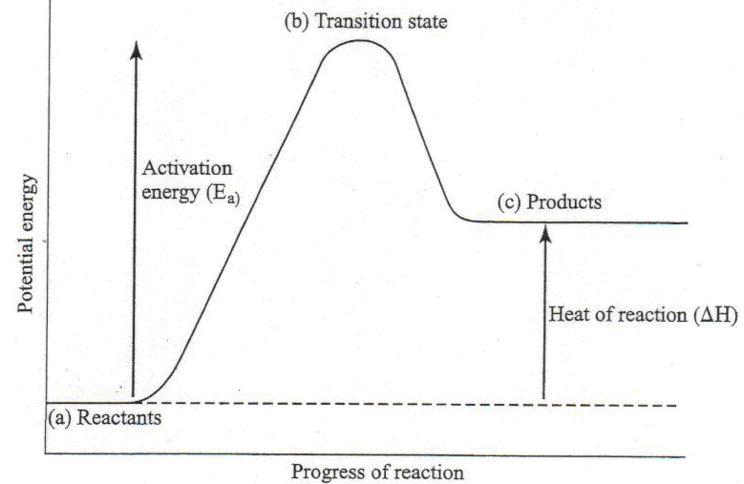
- The activation energy of reactants is
- energy required to break bonds of reactants.
- the minimum energy that is required for a collision to result in a reaction.
- a barrier which must be overcome for the reaction to take place - activation energy barrier.

- When reactant molecules collide, a reaction will only occur if the energy of the collision is equal or greater than the activation energy.

Energy Profile Diagrams for Exothermic and Endothermic Reactions
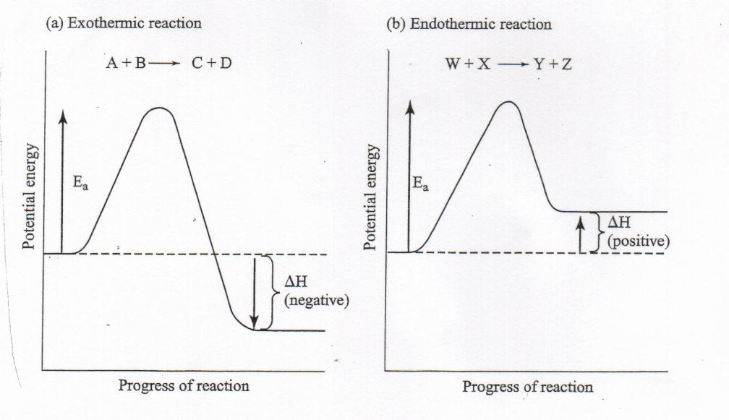

    - Draw energy profile diagrams for the following reactions. Draw the profiles on the same axes and assume that the reactants start with the same energy, 100 kJ.
(Label the axes.)

 | Reaction A | Reaction B
Activation Energy (kJ) | 100 | 120
Heat of reaction – ΔH (kJ) | -50 | 50

H (kJ)

200

100

- Label the reactions as Endothermic and Exothermic.

- Explain the difference between the endothermic reaction and the exothermic reaction in terms of their heat of reaction and what you would expect to observe.

_________________________________________________________________

_________________________________________________________________

_________________________________________________________________

- Assuming all other factors affecting rates of these reactions are the same, identify the faster:
- forward reaction ________________________________
- reverse reaction ________________________________

- Label the transition state for each profile.

- How would the activation energy compare for a rapid reaction and a very slow reaction?

_________________________________________________________________

- How would the heat of reaction compare for burning methane and iron rusting.

_________________________________________________________________

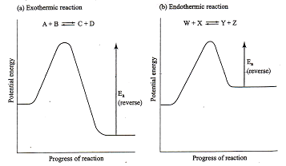
Reversibility of Reactions

- In many reactions there is a significant reaction in the opposite direction in which product molecules react to regenerate the reactants.

- In the reaction (a) A + B ⇋ C + D, the activation energy for the reverse reaction is considerably higher than the reverse reaction for
(b) W + X ⇋ Y + Z

- For a reaction to be reversible, the activation energies of both the forward and reverse reactions must be low enough that sufficient particles will have enough energy for successful collisions.

    - State the difference between a forward and a reverse reaction.

_________________________________________________________________

_________________________________________________________________

_________________________________________________________________
    - Are all reactions reversible? Explain.

_________________________________________________________________

_________________________________________________________________

_________________________________________________________________

APPLYING THE COLLISION THEORY

- The collision theory assumes that if particles are to react they must first undergo an appropriate collision.
- The molecules must:
- collide with enough energy to disrupt the bonds of the reactant molecules.
- collide with an orientation that will break bonds and form others.
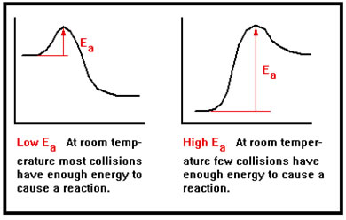

Nature of Reactants
- Slower reactions will have higher activation energies than faster reactions.
- Only a small proportion of molecules in the system have energies greater than that of the activation energy barrier.
- High activation energy - reactions in which strong bonds (or many bonds) need to be broken.
- Few collisions would have sufficient energy to be successful in bringing about a reaction - thus reaction rate would be slow.

- Low E_{a} – not much energy is required to break bonds

Concentration
- Increasing the concentration of a reactant, increase the collision rate.
  - Greater the number of collision, faster rate of reaction.
  - Greater number of particles with sufficient E_{a} to successfully react.

Sub-division
- If the surface area of a reactant is increased, more molecules are exposed to collision.
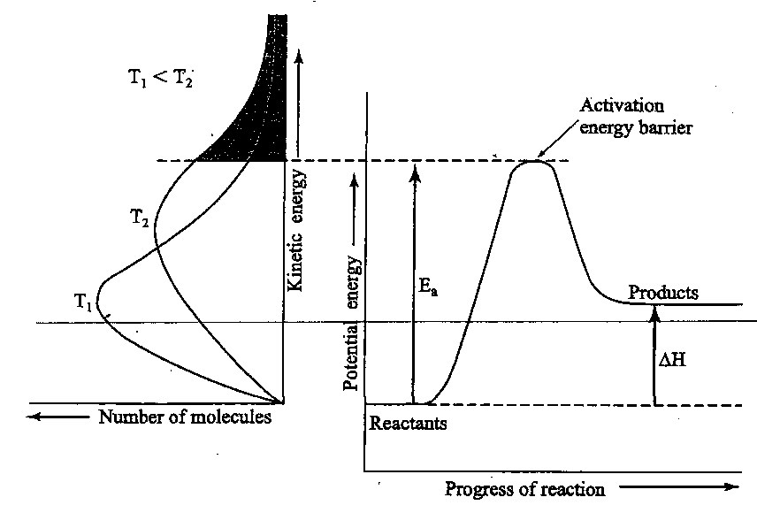

Temperature
- Increase in temperature increases the average kinetic energy of the reacting molecules.
- Increased velocities of the molecules - greater rate of collision and rate of reaction.
- Greater proportion of reactant molecules have sufficient kinetic energy to supply the activation energy needed for reaction.

Catalysts
- A catalyst
  - provide an alternative pathway with lower activation energy.
  - can provide a surface for particles to break apart more easily.
  - can form intermediate compounds in which the bond-breaking and forming process requires less energy than if the reactants alone were involved.

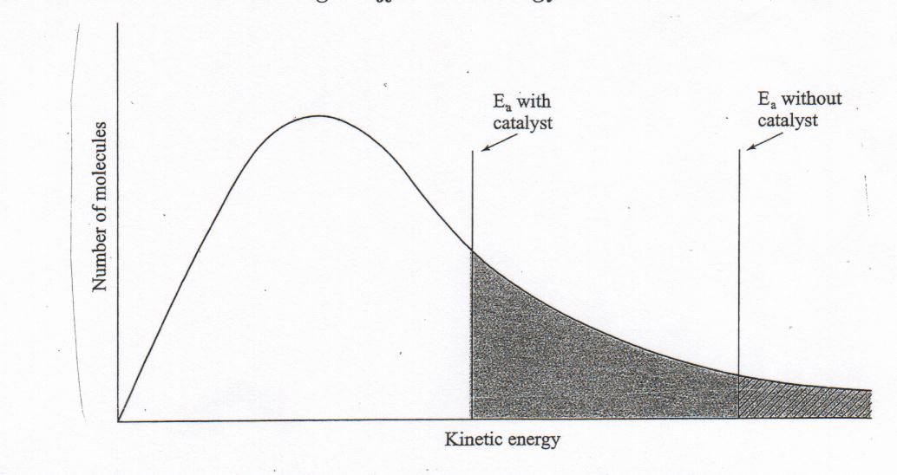
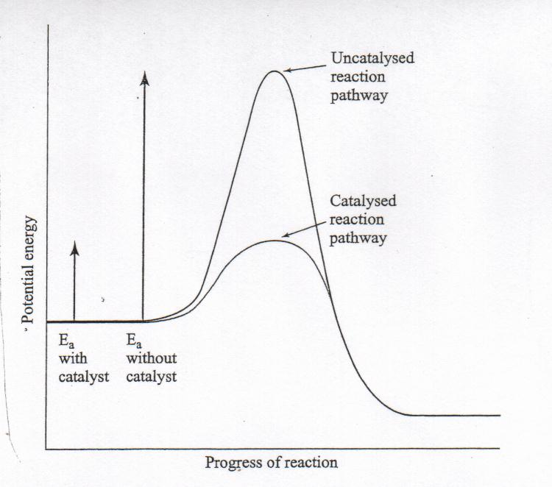

- Less collision energy is required for the reaction - greater proportion of collisions will be successful and the reaction rate will be greater.

- Greater proportion of reactant molecules have sufficient energy to overcome the activation energy barrier.

- Reactions can be carried out at much lower temperatures.

NOTE: When asked to explain anything to do with RATES OF REACTIONS, use the COLLISION THEORY for your answers.

The effect of changes of temperature on chemical systems initially at equilibrium can be predicted by considering the enthalpy changes for the forward and reverse reactions; this can be represented on energy profile diagrams and explained by the changes in the rates of the forward and reverse reactions.

CHEMICAL CHANGES IN CHEMICAL REACTIONS

- Chemical changes are always accompanied with some form of energy change.

Exothermic and Endothermic Reactions

- The chemical energy of a substance is a type of potential energy stored within the substance.
- Enthalpy - the stored chemical energy or the heat content of a substance.
  - denoted by the symbol, H.

Exothermic Reactions

    - Methane burns in air according to the following equation:

CH₄ _{(g)} + 2O₂ _{(g)} CO₂ _{(g)} + 2H₂O _{(g)} + energy

CH₄ _{(g)} + 2O₂ _{(g)}
reactants

This amount of energy is released to the surroundings

Enthalpy (H)
CO₂ _{(g)} + 2H₂O _{(g)}

products

  - a reaction in which energy is released to the surroundings - decrease in enthalpy.
  - the enthalpy is lower for the products than the reactants.
  - the enthalpy difference between the reactants and the products is equal to the amount of energy released to the surroundings.
  - reaction mixture become hotter and transfers heat to the surroundings.

Endothermic Reactions
    - Carbon disulfide can be manufactured according to the following equation:

4C _{(s)} + 8S _{(g)} --> 4CS₂ _{(g)}

4CS₂ _{(g)}

products
Enthalpy (H)

This amount of energy is absorbed from the
surroundings

4C _{(s)} + 8S _{(g)}

reactants

  - a reaction in which energy is absorbed from the surroundings.
  - the enthalpy of the products is greater than that of the reactants.
  - the enthalpy difference between the reactants and the products is equal to energy absorbed from the surroundings.
  - the reaction mixture becomes colder and takes heat from the surroundings.
  - absorbed energy results in the products having a greater enthalpy than the reactants.

STORED CHEMICAL ENERGY

- When chemical bonds are broken:
  - breaking of chemical bonds absorbs energy.
  - formation of chemical bonds releases energy.

- If bonds formed are weaker or fewer than those broken, energy will be absorbed - endothermic reaction.
- If bonds formed are stronger or more numerous than those broken, energy will be released - exothermic reaction.

DESCRIBING ENERGY CHANGES IN CHEMICAL REACTIONS

- ∆H = H(products) – H(reactants).
- heat of reaction = enthalpy of products – heat of reactants.

Reactants Products
E E
N N
T T
H ∆H negative H ∆H positive
A A
L L
P P
Y Y

Products Reactants

- Exothermic  - final enthalpy - less than the initial enthalpy  - ∆H is negative  - loss in enthalpy is accompanied by the release of energy from the system to the surroundings.  - 242 kJ of heat is released when one mole of S reacts with oxygen to form sulphur dioxide.  S _{(s)} + O₂ _{(g)} SO₂ _{(g)} ∆H = -242 kJ  - Can also be written as  S _{(s)} + O₂ _{(g)} SO₂ _{(g)} + 242 kJ | - Endothermic  - final enthalpy is greater than the initial enthalpy  - ∆H is positive  - gain in enthalpy is accompanied by the transfer of energy from the surroundings to the system.  - 131 kJ of heat is needed to turn one mole of S and H₂O into CO.  C _{(s)} + H₂O _{(g)} → CO _{(s)} + H₂ _{(g)} ∆H = +131 kJ  - Can also be written as  C _{(s)} + H₂O _{(g)} + 131 kJ → CO _{(s)} + H₂ _{(g)}

ENERGY CHANGES AND PHYSICAL PROCESSES

- Energy changes associated with physical processes are much smaller than those associated with chemical changes.

Process | Type of Change | ∆H (kJ)
H₂O _{(g)} → H₂O _{(l)} | physical | -44
H₂ _{(g)} + 0.5O₂ _{(g)} → H₂O _{(l)} | chemical | -286
NaOH _{(s)} → Na⁺ _{(aq)} + OH⁻ _{(aq)} | physical | -45
Na _{(s)} + 0.5O₂ _{(g)} + 0.5 H₂ _{(g)} → NaOH _{(s)} | chemical | -425

- When water vapour condenses to liquid:
∆H = -44 kJ - weak hydrogen bonds are formed - small decrease in the potential energy of the system and a release of heat.

- Formation of liquid water from elements H₂ and O₂:
∆H = +286 kJ - involves the breaking and making of strong covalent bonds.

    - For a chemical reaction, if the forward reaction is exothermic then the reverse reaction must be endothermic. Explain the reason for this.

_________________________________________________________________

_________________________________________________________________

_________________________________________________________________

    - The reaction for the self-ionisation of water is an endothermic reaction:
H₂O_{(l)} ⇋ H⁺_{(aq)} + OH⁻_{(aq)}

- write the equation for the forward reaction
- write the equation for the reverse reaction
- sketch an energy profile diagram for the forward reaction
- sketch an energy profile diagram for the reverse reaction

a) b)

IMPOSING CHANGES ON AN EQUILIBRIUM SYSTEM

- Chemical systems at equilibrium will return to a state of equilibrium if an alteration is made.

- As equilibrium is re-established, either the forward or reverse reaction will be favoured.
  - If the forward reaction is favoured, the reaction has shifted to the right.
  - If the reverse reaction is favoured, the reaction has shifted to the left.

The effect of temperature changes

- Reactions are either exothermic or endothermic i.e. when a reaction proceeds it does so accompanied by either a release of energy or an absorption of energy.
- If a reaction is exothermic in the forward direction in an equilibrium it will be endothermic in the reverse direction and vice-versa (law of conservation of energy).
- This is normally shown on an energy profile diagram.

Endothermic change | Exothermic change
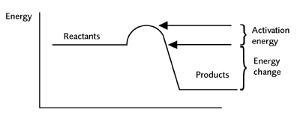
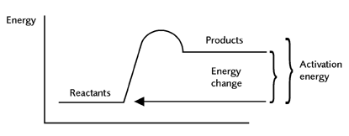

- It can be seen that the activation energy needed for an endothermic change is much greater than for the corresponding reverse exothermic change.

- The higher the activation energy, the greater the effect of temperature on the reaction rate will be. An increase in temperature will affect the number of particles able to react in the endothermic reaction more than the exothermic reaction.

- If the temperature of a system is increased, both reactions will increase. Higher temperature means more collisions above E_{a} for both reactions.

- However, endothermic reactions are more sensitive to change than exothermic reactions.

- Endothermic reactions require energy and will be favoured by an increase in energy (temperature).

- Increasing the temperature of an equilibrium mixture will always favour the endothermic direction over the exothermic process.

- The rate of the endothermic process will increase more than the exothermic process.
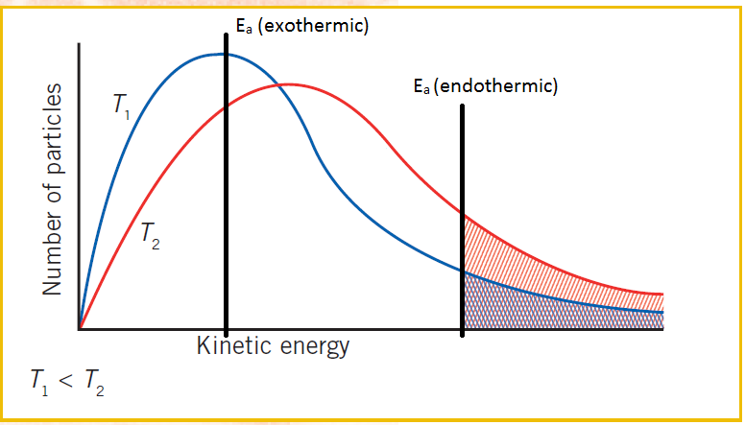
Endothermic process – number of molecules above E_{a} has more than doubled.
Exothermic process – number of molecules above E_{a} has less than doubled.
- The equilibrium will be re-established with new concentrations based on more of the endothermic product (i.e. the product of the endothermic direction of change).
- It can be considered that the endothermic direction is absorbing heat therefore giving it more heat by increasing the temperature will favour it.

- As more of the products of the endothermic reaction are produced, the opposite (exothermic) reaction rate will increase. The rate of the endothermic reaction decreases as the reactants are used up. This continues until a new equilibrium is reached.
- The reverse argument is true for the direction of exothermic change. The exothermic reaction is giving out heat and therefore applying more will hinder this process. Raising the temperature retards the reaction in the exothermic direction.

- Consider the following situation.

  - A₂ + 2B₂ + heat 2AB₂
  - Initially, there is only A₂ and B₂. High numbers of A₂ and B₂ molecules collide to form AB₂.
  - Concentrations of A₂ and B₂ reduce while the concentration of AB₂ increases
  - The rate of the forward reaction slows as the collisions of A₂ and B₂ reduce.
  - The rate of the reverse reaction increases as the AB₂ collisions increase.
  - After about 5 minutes the rates become equal – equilibrium.
  - At the 10 minute mark, the system is heated – both reactions increase.
  - The forward reaction is endothermic and its rate of reaction increases more.
  - The concentration of AB₂ rises.
  - The reverse reaction is exothermic. It slows down. A₂ and B₂ concentrations fall

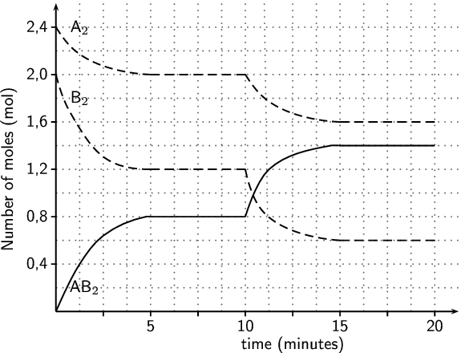
- Example: For the Haber Process equilibrium N₂ + 3H₂ ⇋ 2NH₃ + heat
  - Enthalpy change (forward direction) = -92 kJ (negative sign = exothermic)
  - The reaction is exothermic in the direction of ammonia formation.
  - Increasing the temperature will therefore hinder the forward reaction and favour the reverse reaction.
  - Increasing the temperature will produce less ammonia at equilibrium.

- The opposite is also true. A decrease in temperature will decrease both the forward and reverse reactions.

- The rate of the endothermic reaction will decrease more so the exothermic reaction will be relatively faster.

- Over time, the rate of the endothermic reaction increases, the exothermic reaction decreases – until equilibrium is re-established.

2SO₂ + O₂ ⇋ 2SO₃ + heat N₂ + 3H₂ ⇋ 2NH₃ + heat

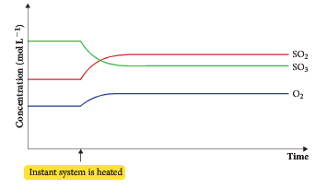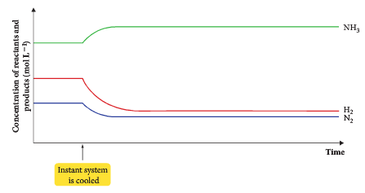

- For example, N₂O_{4(g)} + heat ⇋ 2NO_{2(g)}
  - This reaction is endothermic, as written.

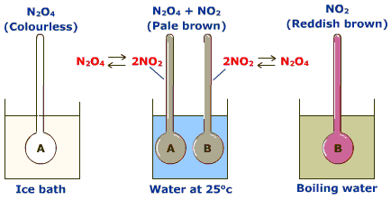
- Adding heat will favour the endothermic reaction – the forward reaction in this case.
- This process will tend to absorb the heat and return the system to equilibrium.
- More NO₂ is produced and the vial turns brown.

- Removing heat favours the exothermic reaction – the reverse reaction in this case.
- This process will tend to release heat and return the system to equilibrium.
- More N₂O₄ is produced and the vial turns more colourless.

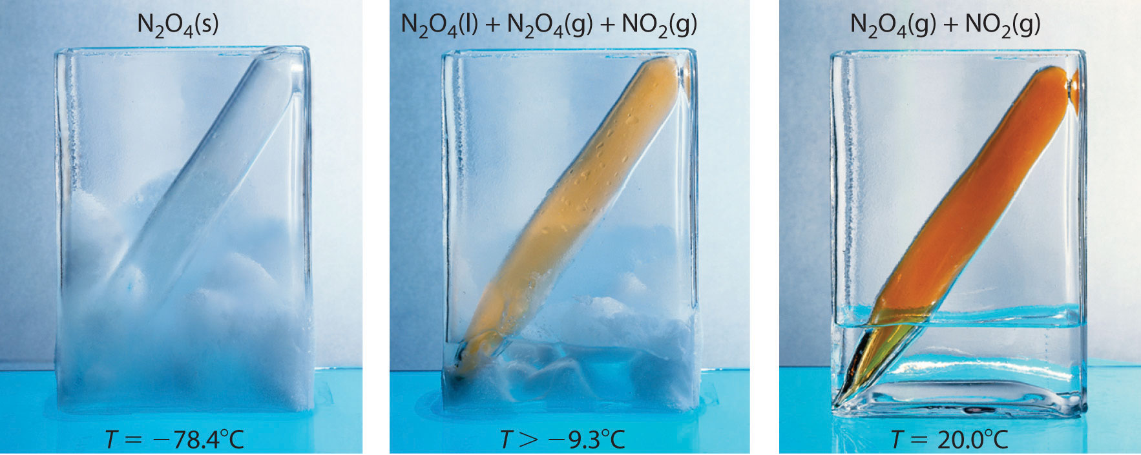

COOL MID HOT

The effects of changes in concentration of solutions and partial pressures of gases on chemical systems initially at equilibrium can be predicted and explained by applying collision theory to the forward and reverse reactions.

The effect of concentration (or partial pressure) changes

- For a system at equilibrium the concentrations of both reactants and products are constant (but not necessarily the same).

- If a further quantity of reactant is added to the mixture already at equilibrium then the equilibrium will make adjustments to re-establish the equilibrium concentrations.

- As more reactants have been added, the only way to adjust this is by making more products (and at the same time using up some of the reactants).
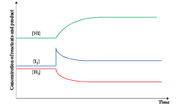
H₂ + I₂ ⇋ 2HI
- This can be explained by considering the rates of the forwards and reverse reactions.

- At equilibrium, the rates of the forward and reverse reactions are equal.

- The rate of a chemical reaction depends on the concentrations of the reactants. The greater the concentration the more collisions occur and the faster the rate of the reaction.
- When more reactants are added, there are more collisions of reactants, the forward rate will now be greater than the reverse rate. The reaction is no longer at equilibrium and the forward reaction proceeds faster than the reverse reaction until the equilibrium conditions are re-established.

- If a system is at equilibrium and one chemical is increased, the rate of the reaction that uses that chemical will increase.
  - The equilibrium will shift to use up this chemical.
  - Its concentration will slowly drop and the rate of this reaction will fall.
  - The rate of the opposite reaction will increase as more of its reactants are produced.
  - Eventually, the rates will be equal and equilibrium is re-established.

    - 2CrO₄²⁻_{(aq)} + 2H⁺_{(aq)} ⇋ Cr₂O₇²⁻_{(aq)} + H₂O_{(l)},


Originally 2 CrO₄²⁻ + 2 H⁺ ⇋ Cr₂O₇²⁻ + H₂O (l)

Add H⁺

H⁺ added 2 CrO₄²⁻ + 2 H⁺ ⇋ Cr₂O₇²⁻ + H₂O (l)

Solution is much more orange
New equilibrium 2 CrO₄²⁻ + 2 H⁺ ⇋ Cr₂O₇²⁻ + H₂O (l)

Original condition - yellow

- Similarly, removal of a component from one side will reduce the rate of its reaction and cause the equilibrium to shift to make more of it.
- This gives a general rule. At equilibrium,
- if we add to the left hand side, we make more of the right hand side.
- if we add to the right hand side, we make more of the left hand side.
- if we remove from the left hand side, we make more of the left hand side.
- If we remove from the right hand side, we make more of the right hand side.

NOTE: only aqueous solutions (aq) can have their concentrations altered. Adding more solid or liquid to a system at equilibrium will not affect the concentration of the solid or liquid.
- Partial pressures of gases can be considered as being the same as concentrations of solutions.
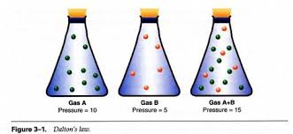
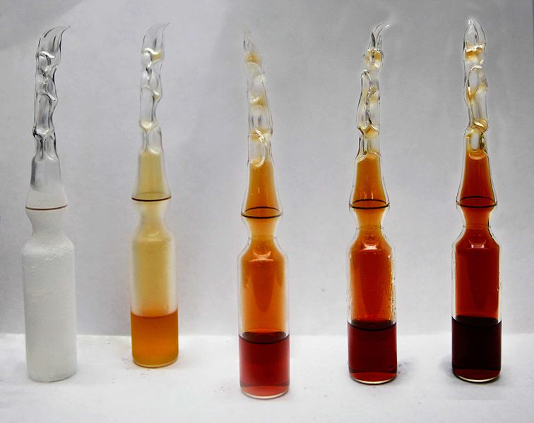


    - N₂O_{4(g)} ⇋ 2NO_{2(g)}
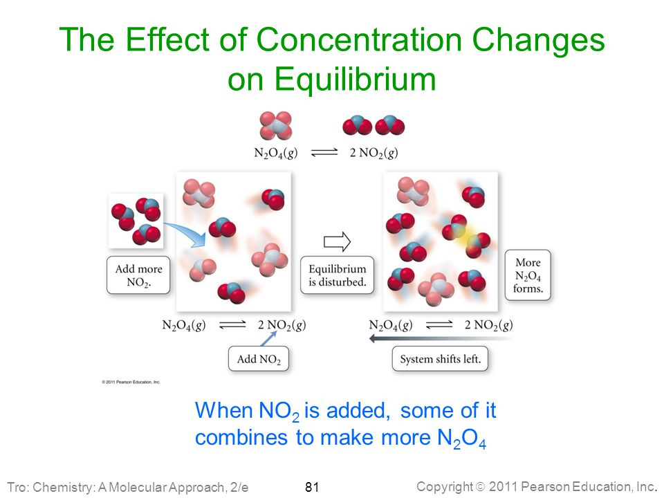

System at equilibrium.
NO₂ added. Vial goes dark brown. Out of equilibrium.
Equilibrium shifts to use up NO₂. More N₂O₄ is made – vial is lighter. Note – it is darker than the original vial.
- NOTE: if an inert gas is added to a system at equilibrium, there will no change.
- The concentrations of the reacting gases have not changed.
- There is no increase or decrease in the partial pressures of the reactants.

    - A reaction that is significant in the formation of smog is one between ozone and nitrogen monoxide. Nitrogen dioxide is a brown gas, the other gases are colourless.

O_{3(g)} + NO_{(g)} ⇋ O_{2(g)} + NO_{2(g)} + 57.5 kJ mol⁻¹

This system is initially at equilibrium.
Predict and explain the effect on the concentration of NO₂ and the colour of the mixture due to the following changes.

  - More O₃ is added.

_________________________________________________________________

_________________________________________________________________

_________________________________________________________________

_________________________________________________________________

_________________________________________________________________

  - NO₂ is removed from the system.

_________________________________________________________________

_________________________________________________________________

_________________________________________________________________

_________________________________________________________________

  - The temperature of the system is decreased.

_________________________________________________________________

_________________________________________________________________

_________________________________________________________________

_________________________________________________________________

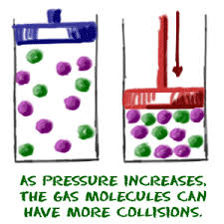

The effect of pressure changes

- Pressure changes only affects gaseous equilibria.
- Pressure changes involve changes in volume.
- If volume is halved, pressure doubles. Since $concentration= \frac{moles}{volume}$ , concentration will double.
- If volume is doubled, pressure halves, concentration halves.
- Reducing the volume and increasing the pressure will increase the number of collisions and, therefore, increase the rate of reaction. Both the forward and reverse reactions will increase.

- However, the side of the equation that has more molecules will involve more collisions. As a consequence, this reaction will be more favoured and will proceed at a greater rate until equilibrium is re-established.

- When a system, at equilibrium, has a changed imposed onto it, the equilibrium responds to the change in conditions by partially counteracting the change in conditions.

- When the pressure is increased on a gaseous mixture at equilibrium, the equilibrium will respond so as to release the applied pressure. In other words the equilibrium will move towards the side of the fewer number of moles.
  - Pressure of a gas is directly proportional to the number of moles of gas.
  - Increase the pressure and it responds by releasing the pressure by making a fewer number of moles.
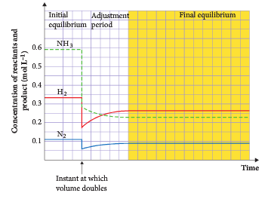
- If pressure is reduced, both reactions slow down (less collisions), but the side with more molecules slows down more – it is more affected.
  - The side with less particles proceeds at a greater rate.
  - Therefore, the system tries to increase pressure by favouring the side with more molecules.

- Pressure changes are only relevant when there are an unequal number of moles of gas on either side of the equilibrium.

- Example: For the Haber Process equilibrium N₂ + 3H₂ ⇋ 2NH₃
four moles gas ⇋ two moles of gas
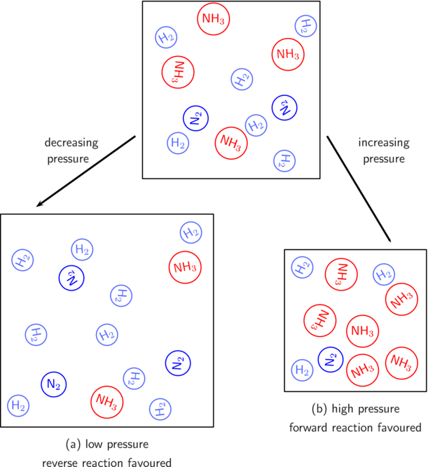
- There are four moles of gas on the left hand side and only two
moles of gas on the right hand side. Increasing the pressure will
move the equilibrium to the right hand side and have the effect of releasing the pressure.

- As the reaction proceeds, concentration of H₂ and N₂ will decrease and concentration of NH₃ will increase.

- Rate of the forward reaction will reduce, rate of the reverse reaction increase – until equilibrium is re-established.

- In a situation where both sides of the reaction have equal numbers of moles, a change in pressure will have no effect on the position of the equilibrium – the equilibrium can’t move in any direction to counteract the change made.

- NOTE: adding a gaseous reactant to a system increases the partial pressure of that reactant. This is the same as increasing the concentration of the reactant. It is not the same concept as increasing the pressure by reducing the volume of the container.

N₂O_{4(g)} + heat ⇋ 2NO_{2(g)}
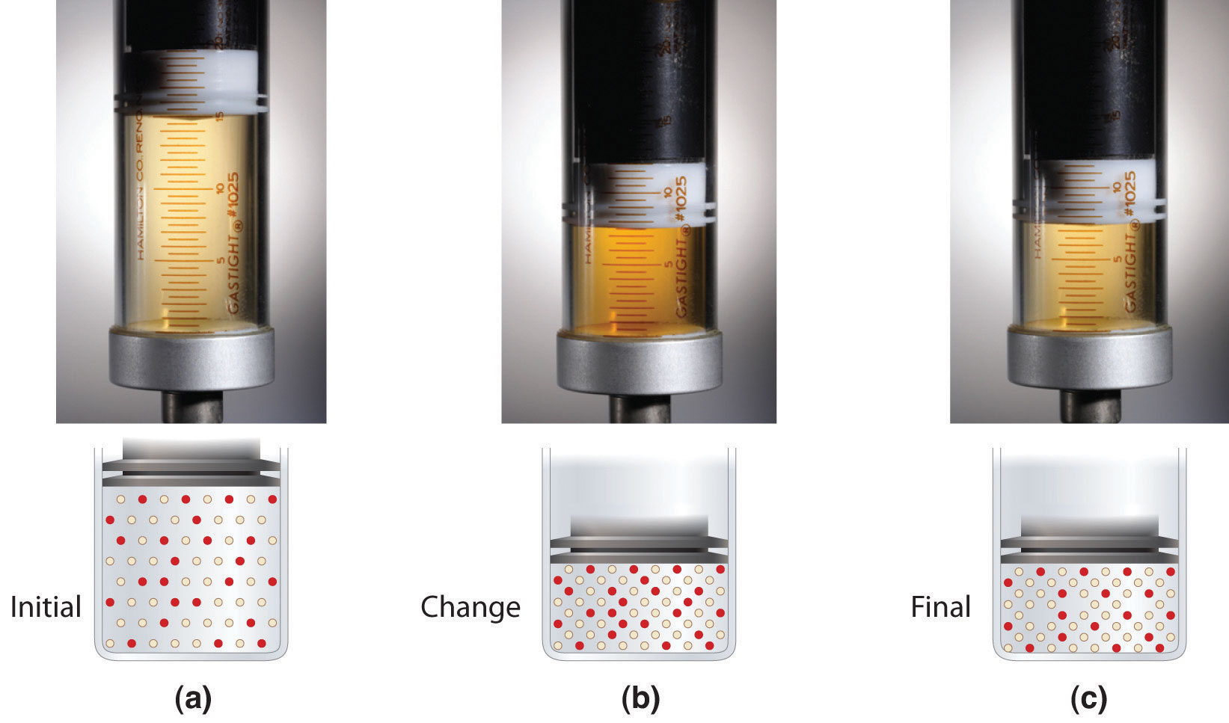

- N₂O₄ and NO₂ at equilibrium.  Brownish colour due to NO₂. | - Volume halved rapidly.  Concentration of both gases rises.  Browner due to increase concentration of NO₂. | - With time, system adjusts to the imposed change.  LCP suggests the side with less molecules is favoured.  That is, more N₂O₄. Therefore, more colourless.

    - Predict and explain the effect on the concentration of NO₂ and the colour of the mixture when the volume of the system is increased. This system is initially at equilibrium.

O_{3(g)} + NO_{(g)} ⇋ O_{2(g)} + NO_{2(g)} + 57.5 kJ mol⁻¹

_________________________________________________________________

_________________________________________________________________

_________________________________________________________________

_________________________________________________________________

_________________________________________________________________
The effects of changes in temperature, concentration of species in solution, partial pressures of gases, total volume and the addition of a catalyst on equilibrium systems can be predicted using Le Châtelier’s Principle.

IMPOSING CHANGES ON AN EQUILIBRIUM SYSTEM

- The concentrations of each species in a system at equilibrium may be changed if any of the following are changed:

Factors Affecting the Equilibrium Position | Factors that DON’T Affect the  Equilibrium Position
Changing the temperature. | The presence of a catalyst.
Changing the concentration. | The degree of sub-division.
Changing the pressure of a gas. | Adding an inert gas (or any gas not changing the partial pressure of the gases in the system)

- Le Chatelier’s principle predicts the effect that these alterations will have on a system at equilibrium. Le Chatelier’s principle states:

If a chemical system at equilibrium is subjected to a change in conditions, the system will adjust to re-establish equilibrium in such a way as to partially counteract the imposed change.
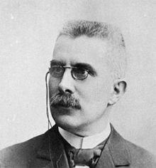
- Le Chatelier’s Principle (LCP) can be used to predict changes in the relative amounts of reactants and products, and to predict the direction shift in equilibrium.

- LCP should NOT be used to explain rates of reactions. Use Collision Theory for this.

- Changing Concentration (or partial pressure)

  - If the concentration of any component changes, the system adjusts to try to counteract the change to return the concentration to the original level.
- The system never quite gets back to its original level – the change is partially counteracted.
- The concentration of any one species can be altered by adding or removing it.

  - In a homogeneous equilibrium (all components in the same phase), increasing one concentration causes a net reaction tending to decrease it.

  - Le Chatelier’s principle suggests:

- increasing the concentration of reactants favours the formation of products.
  - Products are formed when reactants are consumed, i.e. partially counteracting the imposed change.
  - System responds to decrease reactants.
  - Forward reaction is favoured to use up the reactants.
  - The reaction shifts to the right – increasing the concentration or products, decreasing the concentration of reactants.
  - If the partial pressure of a gas increases, the system will adjust to reduce it.

  - For the Haber Process equilibrium N₂ + 3H₂ ⇋ 2NH₃
  - If H₂ is added, the concentration of H₂ increases.
  - Le Chatelier’s Principle suggests that the system will re-establish equilibrium in such a way so as to partially counteract the increase in H₂.
  - This is achieved by favouring the forward reaction and produces more NH₃.
  - The concentration of both N₂ and H₂ are both reduced.

- decreasing the concentration of reactants favours the formation of reactants.
  - Forming more reactants partially counteracts the imposed change.

- increasing the concentration of a product favours the formation of reactants.
  - Reactants are formed when products are consumed, i.e. partially counteracting the imposed change.

- decreasing the concentration of a product favours the formation of products.
  - Forming more products partially counteracts the imposed change.

Problems

- Identify the direction of the favoured reaction when the change is made to the following systems.

 | System | Change | Direction of favoured reaction
1. | N₂O_{4(g)} ⇋ 2NO_{2(g)} | increase NO₂
2. | N₂O_{4(g)} ⇋ 2NO_{2(g)} | increase N₂O₄
3. | 2SO_{2(g)} + O_{2(g)} ⇋ 2SO_{3(g)} | increase SO₂
4. | AgCl_{(s)} ⇋ Ag⁺_{(aq)} + Cl⁻_{(aq)} | decrease Ag⁺
5. | N_{2(g)} + O_{2(g)} ⇋ 2NO_{(g)} | increase NO
6. | CaCO_{3(s)} ⇋ CaO_{(s)} + CO_{2(g)} | increase CO₂

Cr₂O₇²⁻_{(aq)} + 2OH⁻_{(aq)} ⇋ 2CrO₄²⁻_{(aq)} + H₂O_{(l)}
orange yellow

- The above reaction had reached equilibrium when the following changes were made. In the table, write in how these alteration will effect concentrations of other species and the colour of the solution.
 |  |  | Effect on conc. of species
Alteration | Change | Equilib. effect |  | Cr₂O₇²⁻ | OH⁻ | CrO₄²⁻ | H₂O | Soln. colour
Add NaOH
Add
HCl
Add Na₂CrO₄

Add Ba(NO₃)₂

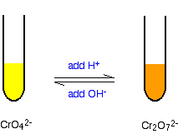
Explanation

- #1
- Alteration Made adding NaOH _{(aq)}
- Imposed Change [OH⁻] is raised
- Effect on Equilibrium favours products
- Effect on the concentration of species as the new equilibrium position is established.
Cr₂O₇⁻² _{(aq)} decreases
2OH⁻ _{(aq)} partially reduced, but higher than original value
CrO₄⁻² _{(aq)} increases
H₂O _{(l)} water is formed - its concentration is unchanged.
- Solution Colour Change yellow to deeper yellow.

- #2
- Alteration Made adding HCl _{(aq)}
- Imposed Change [OH⁻] is lowered
- Effect on Equilibrium favours reactants
- Effect on the concentration of species as the new equilibrium position is established.
Cr₂O₇⁻² _{(aq)} increases (reactants favoured)
2OH⁻ _{(aq)} partially increased, but lower than original value
CrO₄⁻² _{(aq)} decreases
H₂O _{(l)} concentration unchanged.
- Solution Colour Change yellow to orange.
- #3
- Alteration Made adding Na₂CrO₄ _{(s)}
- Imposed Change [CrO₄⁻²] is raised
- Effect on Equilibrium favours reactants
- Effect on the concentration of species as the new equilibrium position is established.
Cr₂O₇⁻² _{(aq)} increases
2OH⁻ _{(aq)} increases
CrO₄⁻² _{(aq)} partially reduced, but higher than original value
H₂O _{(l)} water is formed - concentration is unchanged.
- Solution Colour Change yellow to orange.

- #4
- Alteration Made adding Ba(NO₃)_{2(aq)} - precipitation of BaCrO_{4(s)} (not BaCr₂O₇)
- Imposed Change [CrO₄⁻²] is lowered
- Effect on Equilibrium favours products
- Effect on the concentration of species as the new equilibrium position is established.
Cr₂O₇⁻² _{(aq)} decreases
2OH⁻ _{(aq)} decreases
CrO₄⁻² _{(aq)} partially increased, but lower than original value
H₂O _{(l)} water is formed - concentration is unchanged.
• Solution Colour Change orange to yellow
- Remember increasing the concentration of a substance will cause the system to favour the direction that will decrease the concentration of that substance.

Graphing Concentration Changes
- When considering a Concentration vs Time graph the following will be observed.

  - When a concentration is changed (or a substance is added or taken away), there will be a vertical line on the graph because there is a sudden change in concentration.

  - However, as soon as the change is imposed, the equilibrium will shift so as to counteract the change and eventually establish a new equilibrium.

- It is important to note that in a shift, the concentration of any species only PARTIALLY compensates for the imposed change. THE CONCENTRATION NEVER RETURNS TO WHAT IS ORIGINALLY WAS.

- If the concentration of a species is suddenly INCREASED, it’s Concentration vs. Time graph will look like this:
[ ]
The [ ] in the new equilibrium is NEVER as low as the original. The imposed change is partially counteracted
Concentration is INCREASED at this time
Equilibrium shifts so as to counteract the imposed increase in [ ]

- If the concentration of a species is suddenly DECREASED, it’s Concentration vs. Time graph will look like this:
[ ]
The [ ] in the new equilibrium is NEVER as high as the original
Concentration is DECREASED at this time
Equilibrium shifts so as to counteract the imposed decrease in [ ]

- The extent of increase or decrease in concentration of a substance during a shift is proportional to the coefficient of that substance in the balanced equation.

- Also, the ONLY substance with the “vertical line” is the one that the experimenter actually increased or decreased.

- Consider the equilibrium: N₂O₄ _{(g)} + heat ⇆ 2 NO₂ _{(g)}

  - Assume that the system is at equilibrium in a closed container.
  - The [N₂O₄] = 3.0M and the [NO₂] = 1.0M . The temperature will be kept constant.

0
1
2
3
4
5
6
Time (min)
0.0
1.0
2.0
3.0
[N₂O₄]
[NO₂]
CONC
(mol L⁻¹)

  - At Time = 2 minutes, more NO₂ is injected into the container.
  - Thus the [NO₂] is suddenly increased.

0
1
2
3
4
5
6
Time (min)
0.0
1.0
2.0
3.0
[N₂O₄]
[NO₂]
CONC
(mol L⁻¹)

  - The equilibrium N₂O₄ _{(g)} + heat ⇆ 2 NO₂ _{(g)} will shift to the LEFT in order to counteract the sudden increase in the [NO₂].

  - Thus [NO₂] will decrease and the [N₂O₄] will increase (but only half as much as the [NO₂] decreases due to the 1:2 coefficient ratio!)
1X
2X
0
1
2
3
4
5
6
Time (min)
0.0
1.0
2.0
3.0
[N₂O₄]
[NO₂]
Original equilibrium
At Time = 2min some NO₂ is injected into the container so the [NO₂] suddenly increases.
During the Shift to the LEFT [NO₂] goes down and [N₂O₄] increases (1/2 as much)
The [N₂O₄] has had a NET increase.
CONC
(mol L⁻¹)

In the NEW equilibrium, the [NO₂] has had a slight NET increase from the original equilibrium mixture. New concentration is not as low as original concentration.

  - Rate of reaction graph
0
1
2
3
4
5
6
Time (min)

[N₂O₄]
[NO₂]
At equilibrium, the rates are the same
Rate increases
Rate decreases
New equilibrium – higher than before
NO₂ added. More particles, more collisions. Reaction rate increases.
RATE

- Fe³⁺_{(aq)} + SCN⁻_{(aq)} ⇋ FeSCN²⁺_{(aq)}

- Increasing [SCN⁻_{(aq)}] speeds up the forward reaction, decreasing [Fe³⁺_{(aq)}] and increasing [FeSCN²⁺_{(aq)}] consuming SCN⁻ ions in the process.
New Equilibrium
System at equilibrium
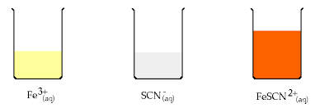
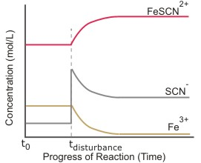

Addition of SCN⁻

Extra SCN⁻
- Equal moles of PCl_{3(g)} and Cl_{(2)(g)} are placed into a closed container and react until they reach equilibrium according to the equation:
PCl_{3(g)} + Cl_{2(g)} ⇋ PCl_{5(g)}
Sketch a graph showing the relative concentrations of all species in the system.

Adding water

- Adding water to a system in equilibrium will dilute all of the components that are dissolved in a solution. This reduces the concentration of all aqueous components.
- The rates of both the forward and reverse reactions will both reduce as there will be less collisions for all reacting species.
- However, the rate of the reaction that uses the greater proportion of aqueous molecule will decrease the most.

- The equilibrium will shift to counteract this change.
  - The reaction that has the most molecules will have its rate gradually increase while the rate of the other reaction will decrease, until equilibrium is re-established.

- When diluted, the system shifts to try to increase the concentration. The side of the equation with MORE particles will be favoured.
- NOTE: the concentrations of the species that are favoured will not exceed their initial concentration as the shift only partially opposes the change.

- The same is true if a solution has water removed from it.
  - All concentrations will increase.
  - Both forward and reverse reactions will increase due to more collisions.
  - The reaction with more particles will increase more.
  - The equilibrium will shift to favour the side with LESS particles.

- NOTE: the concentration of water does not change if water is added or removed from a system.

- [Co(H₂O)₆]²⁺_{(aq)} + 4Cl⁻_{(aq)} ⇋ [CoCl₄]²⁻_{(aq)} + 6H₂O_{(l)}
  - Water is added. The volume is increased and all concentrations will reduce.
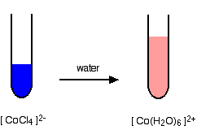
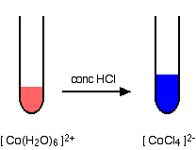
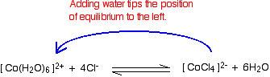

At Time = 2min, water is added. The concentration of all species reduces.
New equilibrium. System has shifted to the left. Solution appears more red
0
1
2
3
4
5
6
Time (min)
0.0
1.0
2.0
3.0
[[CoCl₄]²]]

[[Co(H₂O)₆]²⁺]]

The rate of the forward rxn ⬇
The rate of the reverse rxn ⬆
CONC
(mol L⁻¹)

At Time = 2min, water is added. The concentration of all species reduces.
0
1
2
3
4
5
6
Time (min)

[[CoCl₄]²⁻]
[[Co(H₂O)₆]²⁺]
At equilibrium, the rates are the same
The rate of the reaction with more molecules slows more.
Rate increases
Rate decreases
New equilibrium – lower than before
The rate of the reaction with less molecules slows less.
RATE

    - Consider the reaction H_{2(g)} + I_{2(g)} ⇆ 2HI_{(g)}.
If H₂ is removed, what will happen to
[H₂] ______________________
[I₂] ______________________
[HI] ________________________
Draw a graph of concentration against time and rate against time.

RATE
CONC

HI
HI
I₂
H₂ + I₂
H₂

    - If the following reaction is at equilibrium

4NH_{3(g)} + 5O_{2(g)} ⇋ 4NO_{(g)} + 6H₂O_{(g)}

what would be the effect of the following changes on:
      - the concentration of all species, and
      - the rates of the forward and reverse reactions?

- Adding more O₂ to the system.
[NH₃] _____________________ [O₂] _____________________
[NO] _____________________ [H₂O] _____________________
_____________________ _____________________

- Reducing the concentration of NO.
[NH₃] _____________________ [O₂] _____________________
[NO] _____________________ [H₂O] _____________________
_____________________ _____________________
- Changing the Partial Pressure of a Gaseous System

- If partial pressure of a gaseous species is increased, Le Chatelier’s Principle suggests that the net reaction will occur in a direction that tends to lower the partial pressure of that species (it is the same as concentration).

PCl_{3(g)} + Cl_{2(g)} ⇋ PCl_{5(g)}

- If partial pressure of Cl₂ is increased, the reaction equilibrium moves to the right. That is,
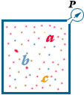
pp(PCl₅) increases
pp (PCl₃) decreases and
pp (Cl₂) is reduced a little.
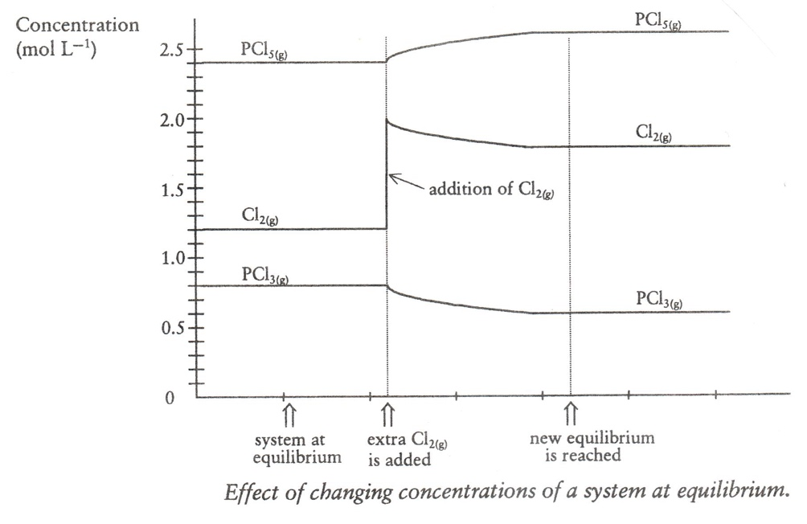
- Note: altering the pressure by adding an inert gas (or any other gas that is not in the system) has no effect on the equilibrium – the partial pressures of other gases are not effected.
  - altering the pressure by adding or removing one gaseous reactant or product is equivalent to altering the concentration of that substance only.

- Changing the Pressure (Volume) of a Gaseous Equilibrium

- According to Le Chatelier’s Principle – if the total concentration of particles is increased, then the system will adjust to re-establish equilibrium in such a way as to partially decrease the concentration of gaseous particles.

- If the volume of the system at equilibrium is reduced (more pressure) the system will oppose this change by favouring the reaction which produces the least number of molecule (least pressure).

- For example, N₂O_{4(g)} ⇋ 2NO_{2(g)}

- If volume of this reaction is halved, the equilibrium moves to the left, as N₂O₄ (1 mole) exerts less pressure than NO₂ (2 moles).

- Decreasing the pressure favours the side of the equilibrium reaction with greater moles of gas (more gas = more pressure).

- Note: volume changes do not alter equilibria in which equal numbers of molecules are on both sides of the equation.
Example: H₂ + Cl₂ ⇋ 2HCl

Problem Set Answers p 58

- Use Le Chatelier’s principle to predict and explain the effect of pressure on equilibrium.

Example #1
- Equilibrium System
2C _{(s)} + O₂ _{(g)} ⇋ 2CO _{(g)}
1 mole of gas 2 moles of gas
- Alteration volume reduced
- Imposed Change ______________________________
- Effect on Equilibrium ______________________________

Example #2
- Equilibrium System
CaCO₃ _{(s)} ⇋ CaO _{(s)} + CO₂ _{(g)}
0 moles of gas 1 moles of gas
- Alteration volume increased
- Imposed Change ______________________________
- Effect on Equilibrium ______________________________

Example #3
- Equilibrium System
I₂ _{(g)} + H₂ _{(g)} ⇋ 2HI _{(g)}
2 moles of gas 2 moles of gas
- Alteration volume increased
- Imposed Change ______________________________
- Effect on Equilibrium ______________________________
- Remember: when the volume is reduced, this produces an increase in both the forward and reverse reactions but if the number of moles is not the same, the two rates will not increase equally.

 | System | Vol. Change | Press. change | Direction of favoured rxn | Why
1. | N₂O_{4(g)} ⇋ 2NO_{2(g)} | increase | decrease |  | Favour products – more moles = increase pressure
2. | 2SO_{2(g)} + O_{2(g)} ⇋ 2SO_{3(g)} | decrease
3. | N_{2(g)} + 3H_{2(g)} ⇋ 2NH_{3(g)} | increase
4. | H_{2(g)} + I_{2(g)} ⇋ 2HI_{(g)} | decrease
5. | CaCO_{3(s)} ⇋ CaO_{(s)} + CO_{2(g)} | decrease
6. | 2SO_{2(g)} + O_{2(g)} ⇋ 2SO_{3(g)} | decrease
7. | 2CO_{(g)} + O_{2(g)} ⇋ 2CO_{2(g} | decrease

Graphing Total Pressure Changes

- Recall, when the volume of a closed container is DECREASED, the TOTAL PRESSURE increases.

- When this happens THE CONCENTRATION OF EVERY GAS IN THE CONTAINER INITIALLY INCREASES. (# of moles per unit volume).

- However, at this point LCP suggest that the equilibrium will shift whichever way it needs to partially counteract the imposed stress.

- With PRESSURE (or VOLUME) changes ALL SUBSTANCE will have vertical lines on the graph at the time the imposed change takes place.

    - Example: N₂O₄ _{(g)} + heat ⇆ 2 NO₂ _{(g)}

  - Assume that the system is at equilibrium in a closed container. The [N₂O₄] = 3.0M and the [NO₂] = 1.0M . The temperature will be kept constant.

0
1
2
3
4
5
6
Time (min)
0.0
1.0
2.0
3.0
[N₂O₄]
[NO₂]
4.0

CONC
(mol L⁻¹)

- At Time = 2 minutes, the volume of the container is suddenly DECREASED. Thus the concentrations of BOTH gases initially increase.

Time (min)
0
1
2
3
4
5
6
0.0
1.0
2.0
3.0
[N₂O₄]
[NO₂]
4.0
The concentration of N₂O₄ will increase more than NO₂.

$$c= \frac{n}{V}$$

If volume halves, concentration doubles.

CONC
(mol L⁻¹)

- In order to counteract the imposed pressure increase, the equilibrium will shift to the side with LESS moles of gas: N₂O₄ _{(g)} + heat ⇆ 2 NO₂ _{(g)}

  - In this case, this would be a shift to the LEFT where [NO₂] will decrease and the [N₂O₄] will increase.
Time (min)
0
1
2
3
4
5
6
0.0
1.0
2.0
3.0
[N₂O₄]
[NO₂]
4.0
As the equilibrium shifts to the LEFT, the increase in the [NO₂] is partially counteracted and the [N₂O₄] increases (1/2 as much)
1X
2X

CONC
(mol L⁻¹)

- Example: 2SO_{2(g)} + O_{2(g)} ⇆ 2SO_{3(g)} at equilibrium in a closed system.
Initially [SO₂] = 2.0M, [O₂] = 3.0M and [SO₃] = 4.0M
At Time = 2 minutes, the volume of the container is suddenly decreased.
Draw and label a graph showing all that would happen in this case.

[SO₃]

[O₂]

[SO₂]

CONC
(mol L⁻¹)

New equilibrium.

Time (min)

- Changing Temperature

- If the temperature of a system is changed, Le Chatelier’s Principle suggests that the system will adjust to partially counteract the change.
  - If the temperature is increased, the equilibrium will shift to use up the added heat.
  - The endothermic reaction will be favoured as it uses up the heat and lower the temperature.
  - If the temperature is reduced, the equilibrium will shift to produce more heat.
  - The exothermic reaction will be favoured to produce heat to raise the temperature.

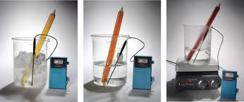
- Note – the system will not return to its original temperature. The change is only partially counteracted.
    - 2NO_{2(g)} ⇋ N₂O_{4(g)} + heat

- The forward reaction is exothermic (-ΔH) and releases heat, increasing the temperature of the system.

- The reverse reaction is endothermic (+ΔH) and absorbs heat, decreasing the temperature of the system.

- If the temperature for the equilibrium is increased, then both reactions speed up, but the endothermic reaction speeds up more, favouring a higher proportion of NO₂. The gas mixture becomes darker.

- This in keeping with Le Chatelier’s Principle. That is, raising the temperature favours the net reaction which tends to lower the temperature.

- NOTE: Heat can be thought of as a reactant or product in a reaction in the same way that concentration is treated. If heat appears on the LHS (endothermic), adding heat will try to use it up and favour the forward reaction.

- Use Le Chatelier’s principle to predict and explain the effect of temperature changes on equilibrium. Answers p 58

Example #1
- Equilibrium System
N₂ _{(g)} + 3H₂ _{(g)} ⇋ 2NH₃ _{(g)} + 92 kJ
left to right (→) heat is released (exothermic)
right to left (←) heat is absorbed (endothermic)
- Alteration raising the temperature
- Imposed Change ______________________________
- Effect on Equilibrium ______________________________

Example #2
- Equilibrium System
2SO₂ _{(g)} + O₂ _{(g)} ⇋ 2SO₃ _{(g)} ∆H = -197 kJ
left to right (→) heat is released (exothermic)
right to left (←) heat is absorbed (endothermic)
- Alteration lowering the temperature
- Imposed Change ______________________________
- Effect on Equilibrium ______________________________

Example #3
- Equilibrium System
C _{(s)} + 3H₂O _{(g)} + 131 kJ ⇋ CO _{(g)} + H₂ _{(g)}
left to right (→) heat is absorbed (endothermic)
right to left (←) heat is released (exothermic)
- Alteration raising the temperature
- Imposed Change ______________________________
- Effect on Equilibrium ______________________________

Example #4
- Equilibrium System
I₂ _{(g)} + H₂ _{(g)} ⇋ 2HI _{(g)} ∆H = +26kJ
left to right (→) heat is absorbed (endothermic)
right to left (←) heat is released (exothermic)
- Alteration lowering the temperature
- Imposed Change ______________________________
- Effect on Equilibrium ______________________________
- Predict the effect of the temperature changes on the following systems.

 | System | Temp Change | Responsive change | Direction favoured | Why
1. | 2SO_{2(g)} + O_{2(g)} ⇋ 2SO_{3(g)} + 198 kJ  left to right () heat released (exothermic)  right to left () heat absorbed (endothermic) | decrease | Heat added  (Increase heat) |  | heat removed – favours exo
2. | N_{2(g)} + 3H_{2(g)} ⇋ 2NH_{3(g)} + 92 kJ | decrease
3. | H_{2(g)} + I_{2(g)} + 52 kJ ⇋ 2HI_{(g)}  left to right () heat absorbed (endothermic)  right to left () heat released (exothermic) | increase
4. | N₂ + O_{2(g)} + 180 kJ ⇋ 2NO_{(g)} | decrease
5. | CaCO_{3(s)} + 179 kJ ⇋ CaO_{(s)} + CO_{2(g)} | increase
6. | AgCl_{(aq)} + 66 kJ ⇋ Ag_{(aq)} + Cl⁻_{(aq)} | decrease
7. | N_{2(g)} + 3H_{2(g)} ⇋ 2NH_{3(g)}  ΔH = -92 kJ  left to right () heat released (exothermic)  right to left () heat absorbed (endothermic) | decrease
8. | Ag_{(aq)} + Cl⁻_{(aq)} ⇋ AgCl_{(aq)}  ΔH = -66 kJ | decrease
9. | CaCO_{3(s)} ⇋ CaO_{(s)} + CO_{2(g)}  ΔH = 179 kJ  left to right () heat absorbed (endothermic)  right to left () heat released (exothermic) | decrease
10. | N₂ + O_{2(g)} ⇋ 2NO_{(g)}  ΔH = 180 kJ | Increase

Graphing Temperature Changes

    - Example: N₂O₄ _{(g)} + heat ⇆ 2 NO₂ _{(g)}
Assume that the system is at equilibrium at a certain temperature. The [N₂O₄] = 3.0M and the [NO₂] = 1.0M at this temperature.

0
1
2
3
4
5
6
Time (min)
0.0
1.0
2.0
3.0
[N₂O₄]
[NO₂]

  - At Time = 2 minutes, the temperature is increased.

  - According to LCP that the equilibrium: N₂O₄ _{(g)} + heat ⇆ 2 NO₂ _{(g)} will shift to the RIGHT, away from the heat term in order to counteract the imposed change.

  - During this shift to the right, the [N₂O₄] will decrease and the [NO₂] will increase. This is not instant, but takes place gradually, until a NEW equilibrium is established.

  - NOTE: in a recent exam, the question stated that the temperature changed SUDDENLY. In this situation, assume that a vertical line would be present.

  - It is also VERY important to note that for every mole of N₂O₄ that is consumed in the shift that 2 moles of NO₂ will be formed (coefficients in balanced equation). So [NO₂] will increase TWICE as much as the [N₂O₄] decreases.
0
1
2
3
4
5
6
Time (min)
0.0
1.0
2.0
3.0
[N₂O₄]
[NO₂]
Original Equilibrium
Shift to the Right is Occurring
[NO₂] increases twice as much as [N₂O₄] decreases
A new equilibrium is established in which [NO₂] is higher and [N₂O₄] is lower
Temperature is increased at Time = 2 min.
CONC
(mol L⁻¹)
The graph shows what happens before, during and after this temperature increase and resulting shift.

1X
2X

- Notice that an increase in a concentration looks like and not like

- Also, a decrease in concentration looks like and not like

- When temperature is changed the rates of the forward and reverse reactions also change.

- If temperature increases - rates of both reactions increases, rate of the endothermic reaction increases more.
0
1
2
3
4
5
6
Time (min)

[N₂O₄]
[NO₂]
At equilibrium, the rates are the same
The rate of the endothermic reaction increases more. NOTE: not an instant change.
Rate increases
Rate decreases
New equilibrium
The rate of the exo thermic reaction increases less.
RATE

- Decrease in temperature decreases both forward and reverse reactions - rate of endothermic reaction decreases more.
- When a system adjusts due to a temperature change, there are no sudden changes in concentration of any species, so there are no vertical lines on the graph.

- Complete the graph showing the changes that would take place if originally [N₂O₄] = 3.0M and the [NO₂] = 2.0M and the temperature is DECREASED at Time = 2.0 min. Draw it so that the new equilibrium is achieved at Time = 4 min.
0
1
2
3
4
5
6
0.0
1.0
2.0
3.0
[N₂O₄]
[NO₂]
Original Equilibrium
Shift to the LEFT is occurring
[NO₂] DEcreases twice as much as [N₂O₄] INcreases
A new equilibrium is established in which [NO₂] is LOWer and [N₂O₄] is HIGHer
Temperature is DECREASED at Time = 2 min.
ENDO
N₂O₄ _{(g)} + heat ⇆ 2 NO₂ _{(g)}
EXO

Time (min)

- Complete the graph below to indicate what happens if the system is cooled.
Concentration
Time
NH₃
H₂
N₂
Heat removed

EXO
N_{2(g)} + 3H_{2(g)} ⇋ 2NH_{3(g)} ΔH = -92 kJ
ENDO

- What conditions favour the production of ammonia? Explain.

_________________________________________________________________

_________________________________________________________________
- If ammonia was at equilibrium with nitrogen and hydrogen in a closed flask, what would be the effect of increasing pressure by adding helium?

_________________________________________________________________

5. Adding a Catalyst

- As catalysts effect the rate of the forward and reverse reactions, there is NO movement of the equilibrium position.
- NOTE: the addition or removal of reactants or products which are present in the solid or liquid phase will not alter the equilibrium constant.
- NOTE: Le Chatelier’s Principle is a predicting tool, not an explanation.
- When you add a catalyst to a system at equilibrium, both the forward and the reverse reactions speed up, so there is no change in the concentrations of any of the species in the mixture.
- Adding a catalyst would have no effect on a graph of Concentration vs. Time!

Examples of common changes that have no effect on equilibrium position.

Example #1
• Equilibrium system
N₂ _{(g)} + 3H₂ _{(g)} ⇋ 2NH₃ _{(g)}
• Alteration to system adding the catalyst Fe/Fe₃O₄
• Effect on equilibrium concentration no effect

Example #2
• Equilibrium system
2C _{(s)} + O₂ _{(g)} ⇋ 2CO _{(g)}
• Alteration to system carbon is finely powdered
• Effect on equilibrium concentration no effect

Example #3
• Equilibrium system
CaCO₃ _{(s)} ⇋ CaO _{(s)} + CO₂ _{(g)}
• Alteration to system removing some CaO _{(s)}
• Effect on equilibrium concentration no effect

Example #4
• Equilibrium system
2H₂O _{(l)} ⇋ 2H₂ _{(g)} + O₂ _{(g)}
• Alteration to system removing some H₂O _{(l)}
• Effect on equilibrium concentration no effect

Example #5
• Equilibrium system
H₂ _{(g)} + Cl₂ _{(g)} ⇋ 2HCl _{(g)}
• Alteration to system reduce volume, increase pressure
• Effect on equilibrium concentration no effect

- Adding or removing large amounts of water from an aqueous equilibrium system may have an effect on equilibrium concentrations as the concentration of all aqueous species will effectively be alter.

- By examining the effects a change made to an equilibrium position, it is possible to work out what change was made.
- Changes in temperature should be gradual. | - Changes in the concentration of one substance will show a sudden spike in that component. | - Changes in pressure to a gaseous system will show two sudden spikes.
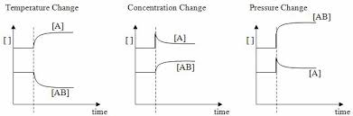

- One line will gradually increase and the other line will gradually decrease. | - One line will gradually increase and the other line will gradually decrease. | - One line will gradually increase and the other line will gradually decrease.

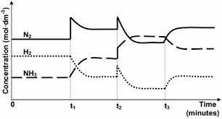
    - Explain what has occurred at
  - t₁_______________________________________________________________________________________________________________________
  - t₂_______________________________________________________________________________________________________________________
  - t₃_______________________________________________________________________________________________________________________
- NOTE: Le Chatelier’s Principle can only be used to predict what will happen to a system at equilibrium if changes are made. It cannot be used to explain what occurs.

The Equilibrium Constant
Equilibrium law expressions can be written for homogeneous and heterogeneous systems; the equilibrium constant (K), at any given temperature, indicates the relationship product and reactant concentrations at equilibrium.
- Equilibrium constant (K) - a numerical value of relative concentrations of products to reactants at equilibrium.
  - For the general reaction: aA + bB ⇋ cC + dD
    - where A and B are reactants
    - C and D are products
    - [ ] is concentration in mol L⁻¹
    - powers a,b,c,d are the coefficients in the equation

K = [C]^{c} [D]^{d} NB: solids and liquids are not included.
[A]ª [B]^{b}

  - K is the equilibrium constant
  - [C]^{c} is the concentration of C raised to the power of c, (the coefficient of C in the equation) and so on for [D]^{d}, [A]ª and [B]^{b}.

- THE EQUILIBRIUM CONSTANT IS FORMED WITH THE PRODUCTS IN THE NUMERATOR (top) AND THE REACTANTS IN THE DENOMINATOR (bottom).

    - If the equilibrium concentration N₂O₄ [N₂O₄] at 100ºC = 0.0045 mol L⁻¹ and the equilibrium concentration of NO₂ [NO₂] at 100ºC = 0.0310 mol L⁻¹ then calculate K for this situation.
N₂O_{4(g)} ⇋ 2NO_{2(g)}

K = NOTE: must write K =
in assessments

    - Four experiments were conducted for dinitrogen tetraoxide forming nitrogen dioxide and reaching equilibrium, at a different temperature to that above. The following concentrations were recorded. Complete the last three columns.
Trial | [N₂O₄]  (mol L⁻¹) | [NO₂]  (mol L⁻¹) | [NO₂]² | [NO₂]  [N₂O₄] | [NO₂]²  [N₂O₄]
1 | 3.476 | 1.048
2 | 2.560 | 0.899
3 | 0.830 | 0.512
4 | 1.950 | 0.785

    - What do you notice about the values in each column?

____________________________________________________________________________

- K is a constant based on the ratio of the [products] and [reactants].
- Aqueous solutions of ions can vary in concentration. Therefore, they are included in the K expression.
- Gases can vary in concentration. Therefore, they are included in the K expression. (pp a conc.)
- Solids and liquids e.g. CaCO₃ _{(s)}, H₂O _{(l)}, have a fixed or constant concentration and do not vary in concentration. Adding a solid or liquid to a system which is at equilibrium cannot change the concentration of it. Therefore, not included in the K expression.

Types of Equilibrium Constants

- Involving aqueous reagents. For example,
HClO_{4(aq)} ⇋ H⁺_{(aq)} + ClO₄⁻_{(aq)}
K = [H⁺] [ClO₄⁻]
[HClO₄]
- Involving water. For example,
NH_{3(aq)} +H₂O_{(l)} ⇋ NH₄⁺_{(aq)} + OH⁻_{(aq)}
K’ = [NH₄⁺] [OH⁻]
[NH₃] [H₂O]
i.e. K’ [H₂O] = [NH₄⁺] [OH⁻]
[NH₃]
Since [H₂O] is constant, then K’ [H₂O] is a constant.
K = [NH₄⁺] [OH⁻]
[NH₃]
- Involving solids or liquids. For example, dissolving CaCO₃ – CaCO_{3(s)} and H₂O_{(l)} have a fixed or constant concentration and do not appear in the expression for K.
CaCO_{3(s)} ⇋ Ca²⁺_{(aq)} + CO₃²⁻_{(aq)}
K = [Ca²⁺] [CO₃²⁻]
(Often called the Solubility Product)
Since [CaCO₃] is basically unchanged, it is not incorporated in K.
Zn_{(s)} + Cu²⁺_{(aq)} ⇋ Cu_{(s)} + Zn²⁺_{(aq)}
K = [Zn²⁺]
[Cu²⁺]
- Involving gases. For example,
2SO_{2(g)} + O_{2(g)} ⇋ 2SO_{3(g)}
K = [SO₃]²
[SO₂]² [O₂]
But [gas] α partial pressure of gas.
So, K = (pp SO₃)²
(ppSO₂)² (pp O₂)

- For a system in equilibrium, K is constant (as long as temperature is not changed).
- Therefore, if the concentration of any reactant or product changes, then the system will adjust and concentrations of other substances will change until K is re-established.

    - At equilibrium, a mixture of N₂O₄ and NO₂ was found to have 0.0123 mol L⁻¹ of N₂O₄ and 0.0623 mol L⁻¹ of NO₂. The concentration of N₂O₄ was increased to
0.830 mol L⁻¹. What would the new concentration of NO₂ be? (No temp change)

    - Define equilibrium constant.

____________________________________________________________________________
____________________________________________________________________________

    - Write the equilibrium expression for 3H_{2(g)} + N_{2(g)} ⇋ 2NH_{3(g)}.

    - Write the equilibrium expression for CaCl_{2(s)} ⇋ Ca²⁺_{(aq)} + 2Cl⁻_{(aq)}.

    - The equilibrium constant for CO_{(g)} + 2H_{2(g)} ⇋ CH₃OH_{(g)} is 14.5 at 483 K. If the concentration of CO and H₂ are both 0.5 mol L⁻¹ and the concentration of CH₃OH is 5 mol L⁻¹. Is the system in equilibrium?

The relative amounts of reactants and products (equilibrium position) can be predicted qualitatively using the equilibrium constant (K_{c})

Size of the Equilibrium Constant

- The size of the equilibrium constant gives an indication of the relative proportions of reactants and products at chemical equilibrium and therefore, the position of the equilibrium.

  - If K > 1 then the reaction favours the forward reaction (products).
  - If K >> 1 (e.g. 10³) then forward reaction is very strongly favoured.
    - [products] >> [reactants]
    - Nearly all the reactants become products.
    - Reaction goes to completion.
    - The position of the equilibrium shifts to the right.
    - 2H_{2(g)} + O_{2(g)} ⇋ 2H₂O_{(g)} K = 2.4 x 10⁴⁷ at 500 K
      - At equilibrium, very large amount of H₂O, low amount of H₂ and O₂.

  - If K < 1 then the reaction favours the reverse reaction (reactants).
  - If K << 1 (e.g. 10⁻³) then reverse reaction is very strongly favoured.
    - [products] << [reactants]
    - Almost none of the reactants become products.
    - Reaction occurs to a very small extent.
    - The position of the equilibrium shifts to the left.
    - H_{2(g)} ⇋ 2H_{(g)} K = 1.2 x 10⁻⁴² at 500 K
      - At equilibrium, very large amount of H₂, low amount of H atom.
  - If K ~ 1, there will be a significant concentration of reactants and products at equilibrium.

    - For example,
- N_{2(g)} + 3H_{2(g)} ⇋ 2NH_{3(g)}
K = [NH₃]²
[N₂] [H₂]³
at 25ºC K = 1.7 x 10⁻¹⁰
K << 1 so reactants are strongly favoured.

- H_{2(g)} + I_{2(g)} ⇋ 2HI_{(g)}
K = [HI]²
[H₂] [I₂]
at 425ºC K = 57
K >> 1 so products are strongly favoured.

- In theory, all reactions are, to some extent, reversible. Reactions with a very large value of K can be considered as going to completion (irreversible).
For example,
CO_{2(g)} + H_{2(g)} ⇋ C_{(s)} + H₂O_{(g)}
K = 2 x 10¹⁷ at 25ºC
- Note :
- The value of K changes if the temperature changes.
- The value of K gives no indication of the rate of reaction.
- Solids and liquids are NOT included in the K expression.
- The value of K DOES NOT change if you alter concentration, pressure or volume.
- The value of K refers only to the equilibrium position.

- Changing the temperature will change the value of the equilibrium constant.
  - For an endothermic reaction, an increase in temperature will favour the formation of products. Therefore, the value of K will increase.
  - For an exothermic reaction, an increase in temperature will favour the formation of reactants. Therefore, the value of K will decrease.

- Write the expression for the equilibrium constant K for the reactions below, the first has been done for you.

a. N_{2 (g)} + 3H_{2 (g)} ⇋ 2NH_{3 (g)}  K = [NH₃]²  [N₂] [H₂]³ | b. 2KClO_{3 (s)} ⇋ 2KCl _{(s)} + 3O_{2 (g)}
c. H₂O_{(l)} ⇋ H⁺ _{(aq)} + OH⁻ _{(aq)} | d. Li₂CO_{3 (s)} ⇋ 2Li⁺ _{(aq)} + CO₃²⁻ _{(aq)}

- At equilibrium, the following reaction, CH₃COOH_{(aq)} ⇋ CH₃COO⁻_{(aq)} + H⁺_{(aq)} has the following concentrations- [CH₃COOH] = 0.92 mol L⁻¹, [CH₃COO⁻] = 1.62 x 10⁻² mol L⁻¹ and

[H⁺] = 1.02 x 10⁻³ mol L⁻¹. Calculate K and comment on the value.

- Yield
  - Refers to how much product can be produced.
  - It is dependent on the position of the equilibrium and the size of the equilibrium.
  - High value of K indicates a high yield.

- Rate
  - How quickly the yield will be achieved.
  - Depends on concentration/pressure, temperature, surface area and catalysts.

- Industrial chemists need to have conditions in a chemical reaction that will maximise the yield and have as high a rate of reaction as possible.

Changes to a system at equilibrium

- If a system in equilibrium has a change imposed onto it (change in temperature, concentration of chemicals, pressure or volume) then the ratio of products to reactants is no longer the same as K. The system is not longer at equilibrium.

- As equilibrium is re-established, either the forward or reverse reaction will be favoured.

- Concentrations will change so their ratio will equal K (assuming temperature is constant).
  - If the forward reaction was favoured, the reaction has shifted to the right and made more products.
  - If the reverse reaction was favoured, the reaction has shifted to the left and made more reactants.

Reaction Quotient – (not in the course but handy to know)
- Equilibrium constant - the ratio between the equilibrium concentrations of products and reactants.

- The ratio between product and reactant concentrations under any conditions is called the reaction quotient, Q.

- For, aA + bB ⇋ cC + dD, under any conditions, the ratio of reactants to products is

  - Q = [C]^{c} [D]^{d}
[A]ª [B]^{b}

  - Q = K only when the system is at equilibrium.
  - If Q < K, there are less products and more reactants than at equilibrium. The forward reaction will be favoured to reach equilibrium.
  - If Q > K, there are more products and less reactants than at equilibrium. The reverse reaction will be favoured to reach equilibrium.

- Consider the following reaction: H_{2(g)} + I_{2(g)} ⇋ 2HI_{(g)} for which K = 57 at 425⁰C. If the concentration of the species are as follows, calculate Q and identify whether the system is at equilibrium. Assume the temperature is 425⁰C in each case.

- [H₂] = [I₂] = 0.020 mol L⁻¹, [HI] = 0.18 mol L⁻¹
- [H₂] = 0.030 mol L⁻¹; [I₂] = 0.015 mol L⁻¹, [HI] = 0.16 mol L⁻¹
- [H₂] = 0.040 mol L⁻¹; [I₂] = 0.035 mol L⁻¹, [HI] = 0.24 mol L⁻¹

Problems Answers p 59

1. Write equilibrium constant expressions for the following reactions:
a. 2SO_{2(g)} + O_{2(g)} ⇋ 2SO_{3(g)} | b. 4NH_{3(g)} + 5O_{2(g)} ⇋ 4NO_{(g)} + 6H₂O_{(g)}

2. H₂ and I₂ are mixed to form HI. When the reaction appears to have finished and equilibrium is reached, the concentration of each gas is measured.

[H₂] = 0.316 mol L⁻¹, [I₂] = 1.316 mol L⁻¹, [HI] = 4.368 mol L⁻¹

Use this data to determine the vakue of K for this reaction at this temperature.

3. From the following equilibrium constants what can be said about the relative concentrations of reactants and products at equilibrium?
a. 2H_{2(g)} + O_{2(g)} ⇋ 2H₂O_{(g)}
K = 2 x 10⁸¹ at 25ºC
b. 2CO_{2(g)} ⇋ 2CO_{(g)} + O_{2(g)}
K = 4 x 10⁻⁹² at 25ºC.
c. CO_{2(g)} + H_{2(g)} ⇋ CO_{(g)} + H₂O_{(g)}
K = 0.11 at 400ºC
d. CO_{(g)} + H₂O_{(g)} ⇋ CO_{2(g)} + H_{2(g)}
K = 1 x 10² at 25ºC

Problems
1. 1.00 mol each of H_{2(g)} and I_{2(g)} were placed in a closed 1.00 L flask and heated to 425ºC. When chemical equilibrium was established the remaining concentrations of H_{2(g)} and I_{2(g)} were 0.21 mol L⁻¹, the rest having been converted to HI_{(g)} according to the following equation:

H_{2(g)} + I_{2(g)} ⇋ 2HI_{(g)}

a. Calculate the equilibrium concentration of HI_{(g)}

b. Plot qualitative graphs showing the following:
(i) The change in concentration of H₂, I_{2(g)} and HI_{(g)}.
RATE
CONC

(ii) The rate of the forward and reverse reactions until equilibrium was established. Mark on the graphs the time at which equilibrium was reached.

c What would be the characteristics of this system once equilibrium was established?
____________________________________________________________________________
____________________________________________________________________________

2. A state of chemical equilibrium for the following reaction can be established at a temperature of 900ºC.
CaCO_{3(s)} ⇋ CaO_{(s)} + CO_{2(g)}

This equilibrium state occurs when the pressure of CO₂ reached 1.04 atm. Explain why such an equilibrium state can be reached in a sealed container but not in a container open to the atmosphere.

____________________________________________________________________________
____________________________________________________________________________

3. Use collision theory to explain the effect of removing hydronium ion from the following mixture at equilibrium.
HCO₃⁻_{(aq)} + H₂O_{(l)} ⇋ CO₃⁻_{(aq)} + H₃O⁺_{(aq)}
____________________________________________________________________________
____________________________________________________________________________
____________________________________________________________________________
____________________________________________________________________________

- For the reaction
N₂O_{4(g)} ⇋ 2NO_{2(g)} ΔH = +57.2 kJ
what would be the effect of each of the following changes.
Adding N₂O₄?
Adding NO₂?
Adding heat?
Removing N₂O₄?
Increasing pressure?

- Sketch a graph showing the relative concentrations of all species over time if equal amounts of NO and O₂ are introduced to a closed system and are allowed to reach equilibrium.
2NO_{(g)} + O_{2(g)} ⇋ 2NO_{2(g)}

CONC

LE CHATELIER’S PRINCIPLE - Summary
- Change made to a chemical system in equilibrium, equilibrium will be disturbed.

- System will adjust to a new state of equilibrium with new concentrations of species involved.

- Changes that can be made to equilibrium systems:
  - Consider following hypothetical reaction:
A_{(g)} + B_{(g)} + 180 kJ ⇋ C_{(l)} + D_{(s)}
Change to Equilibrium | Reactions Favoured
Temperature increase | Endothermic reactions – favour formation of C and D
Temperature decrease | Exothermic reactions – favour formation of A and B
Concentration increase of A and / or B | Favours formation of C and D
Concentration increase of C | No effect
Increase in pressure – increases concentration of all gaseous species since volume is decreased. | Favours formation of C and D
Increase concentration of D. | No effect on equilibrium
Introduce a catalyst | No effect on equilibrium

Temperature Change
N_{2(g)} + O_{2(g)} + 180 kJ ⇋ 2NO_{(g)}
- Raising temperature, equilibrium shifts to use up added heat – favours product formation.

- Stoichiometrically, the increase in concentration of NO is double the decrease of either N₂ or O₂.

N₂ new equilibrium reached

Conc. O₂

NO

Temp. Increased Time

- Reason for shift is that forward reaction rate is increased more than reverse reaction rate.

- Equilibrium is established when these rates again become equal.

Concentration Change

- Concentration of species in equilibrium system increase by adding more of that species.

- Equilibrium will shift to reduce new concentration back towards the original concentration.
H₂ _{(g)} + I₂ _{(g)} ⇋ 2HI _{(g)}
Added iodine vapour will cause equilibrium to shift to the right.

HI

Conc. new equilibrium reached

I₂

H₂

Iodine added Time

Volume Change

- Volume of gaseous equilibrium systems is reduced, the concentration of all species increased.

2NO₂ _{(g)} ⇋ N₂O₄ _{(g)}

- Increased pressure on the system reduces volume, increases the concentration of both species.

- Because more particles of NO₂ equilibrium shifts to favour formation of N₂O₄.

- If there are same number of moles / molecules of each side, no shift in equilibrium – all concentrations increase or decrease in same proportion.

- Addition of a catalyst has no effect on equilibrium concentrations.

- Addition or removal of products which are solids, or liquids has no effect on equilibrium concentrations.

- The removal or addition of water may affect equilibrium concentrations of aqueous species.

- NOTE: Use Collision Theory to explain rates of reaction increases or decreases.
Use Le Chatalier’s Principle to predict yield increases or decreases AND
use Collision Theory to explain.

Examples to work through: Answers p 60

- Le Chatelier’s Principle states that when a system at equilibrium is subjected to a stress, the system will shift its equilibrium point in order to relieve the stress. Complete the following chart by writing left, right or none for equilibrium shift, and decrease, increase or same for the concentrations of reactants and products, and of the value of K.

N_{2 (g)} + 3H_{2 (g)} ⇋ 2NH_{3 (g)} + 22.0 kcal
Stress | Equilibrium Shift | [N₂] | [H₂] | [NH₃] | K
Add N₂ | right  favours forward | decreases | decreases | increases | same

Add H₂

Add NH₃

Remove N₂

Remove H₂

Remove NH₃

Increase temperature

Decrease temperature

Increase pressure

Decrease pressure

NaOH_{(s)} ⇋ Na⁺ _{(aq)} + OH⁻ _{(aq)} + 10.6 kcal
Stress | Equilibrium Shift | Amount of NaOH_{(s)} | [Na⁺] | [OH⁻] | K
Add NaOH_{(s)}
Add NaCl_{(s)}

Add KOH_{(s)}

Add H⁺

Increase temperature
Decrease temperature
Increase pressure
Decrease pressure

Industrial Processes - Applying The Principles Of Equilibrium And Reaction Rate

- In industry, a reaction process requires conditions that produce the maximum amount of the desired product for the minimum cost. Therefore, three factors should be considered:-

- Reaction rate – determines how quickly products are formed. Methods of increasing reaction rates are
- raising the temperature - more particles have energy greater than activation energy.
- increasing surface area – make solids into powder, liquids into mists.
- increasing the concentration
- using catalysts - lowers activation energy. If an exothermic reaction is ideal, low temperatures are favoured. Catalyst means less energy (heat) will be required.

Note: It is not really this simple. Factors affecting the equilibrium and the cost of the process must be considered.

- Equilibrium – we must consider the yield of products, that is, the amount of products formed at equilibrium. Reaction conditions (temperature and pressure) can be varied to favour products.

- Economic Factors - that is, the cost of providing reaction conditions:-
- High temperatures – costly in terms of energy requirements.
- High pressure – must consider cost of building and maintaining equipment.
- Catalysts – cheap ones need to be used if possible.

- The Haber Process.

- Ammonia, (NH₃) is used in the manufacture of fertilisers [e.g. NH₄NO₃, (NH₄)₂SO₄, (NH₄)₃PO₄ and (NH₂)CO], explosives and as a cleaning agent.

- It is manufactured by the Haber process which utilises the equilibrium reaction of nitrogen with hydrogen:

N_{2(g)} + 3H_{2(g)} ⇋ 2NH_{3(g)} ∆H = -92kJ

- This reaction is extremely slow under normal conditions, however, by controlling the reaction conditions, as in the Haber process, it is possible to economically synthesise ammonia from this reaction.

- The Haber process, description and explanation of conditions

Condition #1

Moderate Temperature - 500ºC.
• Effect on Rate
Increases rate of reaction.
• Explanation of Effect on Rate
Reacting particles have a higher kinetic energy, thus a greater percentage of collisions are successful (have greater energy than activation energy)
• Effect on Yield

Decreases yield
• Explanation of Effect on Yield (Using Le Chatelier’s Principle)
Endothermic reaction favoured causing the decomposition of NH_{3(g)}.
- NOTE: This is what is known as a compromise temperature. Needs to be high enough for particles to react but not too high that it favours the reverse reaction.

Condition #2

High pressure of 350 Atm.
• Effect on Rate
Increases rate of reaction.
• Explanation of Effect on Rate
Higher pressure cause a higher concentration of reacting particle and this results in a greater rate of collisions.
• Effect on Yield

Increases yield
• Explanation of Effect on Yield (Using Le Chatelier’s Principle)
Favours the formation of NH₃ _{(g)} as less molecules

Condition #3

Catalyst - iron/iron oxide.
• Effect on Rate
Increases rate of reaction.
• Explanation of Effect on Rate
Provides and alternative reaction path of lower activation energy, thus a greater percentage of collisions have greater energy than activation energy.
• Effect on Yield
no effect on yield
• Explanation of Effect on Yield (Using Le Chatelier’s Principle)
increases the rate of forward and reverse reactions equally - neither reaction favours.

- The Contact Process

- The manufacture of sulfuric acids is achieved by using the Contact Process. Sulfur dioxide is first produced by burning liquid sulfur: S_{8(l)} + O_{2(g)} 8SO_{2(g)}

- The sulfur dioxide is oxidised by oxygen to sulfur trioxide in a reversible reaction:

2SO_{2(g)} + O_{2(g)} ⇋ 2SO_{3(g)} + 198 kJ

(i) Temperature
A high yield is favoured by low temperature, but the reaction rate is then very slow.
At temperatures below 400ºC, the catalyst is inactive, so progressively lower temperatures from about 600ºC down to 420ºC are used over successive catalyst beds to achieve progressively higher yield at a fast overall rate.

(ii) Pressure
High pressures would increase both rate and yield, but these are adequately controlled by the temperature and catalyst.

Thus, costs are saved by using a pressure only slightly in excess of 1 atmosphere – sufficient to keep gases circulating through the system.

(iii) Catalyst
A vanadium pentoxide, V₂O₅, catalyst is used. This provides a satisfactory rate of reaction, but does not affect the equilibrium yield.

- Sulfur trioxide is then absorbed by 98% sulfuric acid to form oleum – effectively 99.5% sulfuric acid.
H₂SO_{4(l)} + SO_{3(g)} ⇋ H₂S₂O_{7(l)}

- The oleum is diluted with water to produce 98% sulfuric acid.
H₂S₂O_{7(l)} + H₂O_{(l)} ⇋ 2H₂SO_{4(l)}

- This is the normal concentration of commercial concentrated sulfuric acid – 18 mol L⁻¹.

Levels of carbon dioxide in the atmosphere are rising and have a significant impact on global systems, including surface temperatures. The increasing level of carbon dioxide in the atmosphere causes more carbon dioxide to dissolve in the ocean producing carbonic acid and leading to increased ocean acidity. This is predicted to have a range of negative consequences for marine ecosystems such as coral reefs. Calcification is the process which results in the formation of calcium carbonate structures in marine organisms. Acidification shifts the equilibrium of carbonate chemistry in seawater, decreasing the rate and amount of calcification among a wide range of marine organisms. The United Nations Kyoto Protocol and the Intergovernmental Panel on Climate Change aim to secure a global commitment to reducing greenhouse gas emissions over the next few decades.

ANSWERS

Example #1
- Imposed Change increased pressure
- Effect on Equilibrium favours reactants

Example #2
- Imposed Change reduced pressure
- Effect on Equilibrium favours products

Example #3
- Imposed Change reduced pressure
- Effect on Equilibrium no effect
 | System | Vol. Change | Press. change | Direction of favoured rxn | Why
2. | 2SO_{2(g)} + O_{2(g)} ⇋ 2SO_{3(g)} | decrease | increase | → | Favour products – less moles
3. | N_{2(g)} + 3H_{2(g)} ⇋ 2NH_{3(g)} | increase | decrease | ← | Favour reactants – more moles
4. | H_{2(g)} + I_{2(g)} ⇋ 2HI_{(g)} | decrease | increase | No change | Equal moles both sides
5. | CaCO_{3(s)} ⇋ CaO_{(s)} + CO_{2(g)} | decrease | increase | ← | Favour reactants – less moles
6. | 2SO_{2(g)} + O_{2(g)} ⇋ 2SO_{3(g)} | decrease | increase | → | Favour products – less moles
7. | 2CO_{(g)} + O_{2(g)} ⇋ 2CO_{2(g} | decrease | increase | → | Favour products – less moles

Example #1
- Alteration raising the temperature
- Imposed Change heat added
- Effect on Equilibrium favours reverse reaction

Example #2
- Alteration lowering the temperature
- Imposed Change heat removed
- Effect on Equilibrium favours forward reaction

Example #3
- Imposed Change heat added
- Effect on Equilibrium favours forward reaction

Example #4
- Imposed Change heat removed
- Effect on Equilibrium favours reverse reaction

 | System | Temp Change | Responsive change | Direction favoured | Why
2. | N_{2(g)} + 3H_{2(g)} ⇋ 2NH_{3(g)} + 92 kJ | decrease | Increase heat | → | Heat removed – favours exo
3. | H_{2(g)} + I_{2(g)} + 52 kJ ⇋ 2HI_{(g)}  left to right () heat absorbed (endothermic)  right to left () heat released (exothermic) | increase | Remove heat | → | Heat added –favours endo
4. | N₂ + O_{2(g)} + 180 kJ ⇋ 2NO_{(g)} | decrease | Increase heat | ← | Heat removed – favours exo
5. | CaCO_{3(s)} + 179 kJ ⇋ CaO_{(s)} + CO_{2(g)} | increase | Remove heat | → | Heat added –favours endo
6. | AgCl_{(aq)} + 66 kJ ⇋ Ag_{(aq)} + Cl⁻_{(aq)} | decrease | Increase heat | ← | Heat removed – favours exo
7. | N_{2(g)} + 3H_{2(g)} ⇋ 2NH_{3(g)}  ΔH = -92 kJ  left to right () heat released (exothermic)  right to left () heat absorbed (endothermic) | decrease | Increase heat | → | Heat removed – favours exo
8. | Ag_{(aq)} + Cl⁻_{(aq)} ⇋ AgCl_{(aq)}  ΔH = -66 kJ | decrease | Increase heat | → | Heat removed – favours exo
9. | CaCO_{3(s)} ⇋ CaO_{(s)} + CO_{2(g)}  ΔH = 179 kJ  left to right () heat absorbed (endothermic)  right to left () heat released (exothermic) | decrease | Increase heat | ← | Heat removed – favours exo
10. | N₂ + O_{2(g)} ⇋ 2NO_{(g)}  ΔH = 180 kJ | Increase | Remove heat | → | Heat added –favours endo

Problems

1.

2. K = [HI]²/[H₂].[I₂]

= (4.368)²/(0.316).(1.316)

= 45.9

3.
a. 2H_{2(g)} + O_{2(g)} ⇋ 2H₂O_{(g)}
K = 2 x 10⁸¹ at 25ºC products favoured as K > 1
b. 2CO_{2(g)} ⇋ 2CO_{(g)} + O_{2(g)}
K = 4 x 10⁻⁹² at 25ºC. reactants favoured as K < 1
c. CO_{2(g)} + H_{2(g)} ⇋ CO_{(g)} + H₂O_{(g)}
K = 0.11 at 400ºC very slightly favours reactant
d. CO_{(g)} + H₂O_{(g)} ⇋ CO_{2(g)} + H_{2(g)}
K = 1 x 10² at 25ºC slightly favours products
Problems
1.
a.
initially 2 moles of gas
final [H₂] [I₂] = 0.21 mol L⁻¹ x 2 = 0.42 or [H₂]_{used} = 1 – 0.21 = 0.79 mol L⁻¹
final [HI] = 2.0 – 0.42 mol [HI]_{produced} = 2 x 0.79
= 1.58 mol L⁻¹ = 1.58 mol L⁻¹
b.
CONC
[HI]
[H₂]
[I₂]
RATE
Reverse
Forward

c Concentrations of [H₂], [I₂] and [HI] will remain constant with time. Rates of forward and reverse reactions will be equal.

2. In an open container, the carbon dioxide gas would escape and be unavailable for reverse reaction.

3. As H₃O⁺ is used up there will be less collisions involving H₃O⁺ so the reverse reaction will slow down.
The forward reaction will have relatively higher concentrations of reactants and will be comparatively faster, so, more H₃O⁺ will be produced.

- a) Adding N₂O₄? Favours rxn. to reduce N₂O₄ NO₂ ⬆ N₂O₄ ⬇
Adding NO₂? Favours rxn. to reduce NO₂ NO₂ ⬇ N₂O₄ ⬆
Adding heat? Favours rxn. to reduce heat NO₂ ⬆ N₂O₄ ⬇
Removing N₂O₄? Favours rxn. to increase N₂O₄ NO₂ ⬇ N₂O₄ ⬆
Increasing pressure? Favours rxn. to reduce pressure NO₂ ⬇ N₂O₄ ⬆

- Sketch
CONC

[NO₂]
[O₂]
[NO]

Stress | Equilibrium Shift | [N₂] | [H₂] | [NH₃] | K
Add H₂ | right | decrease | decrease | increase | same
Add NH₃ | left | increase | increase | decrease | same
Remove N₂ | left | increase | increase | decrease | same
Remove H₂ | left | increase | increase | decrease | same
Remove NH₃ | right | decrease | decrease | increase | same
Increase temperature | left | increase | increase | decrease | decrease
Decrease temperature | right | decrease | decrease | increase | increase
Increase pressure | right | decrease | decrease | increase | same
Decrease pressure | left | increase | increase | decrease | same

Stress | Equilibrium Shift | Amount of NaOH_{(s)} | [Na⁺] | [OH⁻] | K
Add NaOH_{(s)} | no change as solid | increase | same | same | same
Add NaCl_{(s)} | left | increase | increase | decrease | same
Add KOH_{(s)} | left | increase | decrease | increase | same
Add H⁺ | right | decrease | increase | decrease | same
Increase temperature | left | increase | decrease | decrease | decrease
Decrease temperature | right | decrease | increase | increase | increase
Increase pressure | same (no gas) | same | same | same | same
Decrease pressure | same (no gas) | same | same | same | same

